Mrs P.W.Hutton, headmistress from 1972 to 1987, wrote, “Our history shows how from very small beginnings the School, in spite of many problems and setbacks, has grown to its present size. The achievements of the past serve as an inspiration to us and we can face the future with confidence, knowing that our present teachers and pupils, and those who will come to us in the future, will not only maintain the proud traditions of our School but will add to them and to the luster of our good name.”

Going back in time to 1877, Dominee Braam Steytler, the founder of our school, made one of the best decisions in his life – to establish a quality school for girls only. Together with the synod of the Nederduitse Gereformeerde Kerk of the 1860s and ‘70s, they saw fit to fight for their belief in establishing a school for young girls. At the time, this was most unusual, as co-educational schools were then the norm. Their visionary insight and perseverance in striving to establish a quality school for girls only has stood the test of time.

This building in North Street was occupied from 1962 and celebrated a 50 years old birthday in 2012. It took 23 years to acquire this “new” school building. The first move to motivate for a new school building had been made by Miss G.A Schmidt, 8th lady principal from April 1930 to March 1944, who after her retirement and before her death, managed to visit the school to see the outcome of her vision of building a new school to house the growing number of Riebeek Girls. The planning, fun-raising and work continued throughout the 9th lady principal’s tenure of Miss J.A.D Miller from April 1944 to December 1956. And finally, also through the 10th lady principals tenure at Riebeek College , Miss Jean Bartlett, from January 1957. (By the way, this was the year I was in Grade 1, which was then known as Sub A). In September of Miss Bartlett’s first year at the school, when Riebeek was celebrating its 80th School Birthday at a successful Garden Party in Magenis Park, Miss Bartlett was able to announce to the assembled 200 guests and 450 pupils, that Riebeek College (together with two other local schools) topped the priority list on the department’s building programme. The contractor for the new buildings, was Messrs P. Calitz and Son – whose grandson, Mr. Anton Calitz, is a present a teacher at Riebeek College. Mr. Calitz, obviously did not follow in the footsteps of his grandfather in the building industry. However, it is quite surreal having the grandson of the man who built the school, walking along these corridors as a teacher. Mr Calitz, I think I must make you responsible for the maintenance and upkeep of these buildings – in honour of your grandfather! However, I have had time to observe your talent and I don’t think you quite fit this mould! The cartage contractor responsible for moving all the furniture, boxes and movable property was Messrs M. Laas – whose daughter-in-law, Jackie Piederit (Laas/Cairney), was an ex-Riebeek girl, whose daughters subsequently attended Riebeek College. Many parents were also involved and transported to the new building over the weekend, many, many boxes that had been packed by the senior school girls. The following is an adaptation of the RCOGA minutes of their first meeting in the staff room of the new school: “ This delightful meeting was the result of the kind invitation from the Head Mistress, Miss Bartlett, who sacrificed on of her few open evenings to conduct us through the new school. The school was lit up completely for the first time in our honour and what a sight it was. It looked magnificent.” The new College Hill Preparatory School – compromising the sub stds and the std1 (today known as grades 1 – 3) Girls and boys of both Riebeek and Muir College was established in January 1962 in the “old” Riebeek College building in Church street. So, when College Hill was established, they were still housing all Riebeek College girls for a few months, until they could move to the new building – where we are established today. Doctor Jean van Onselen, was the first lady Principal of College Hill. I have no doubt that she must have been delighted to see all the Riebeek girls move out of her newly established school. It was not until Monday 26 March 1962 that the first classes were held in the new school. School started at 08:15 and ended at 13.45. Teaching commenced in the new classrooms after the teachers and groups of pupils had spent the weekend unpacking and getting everything organized. I would now like to read an account of this event from a letter written by Miss Jean Bartlett, who was the lady Principal responsible for the move: “Happily there were no serious mishaps, although there were anxious moments, most memorable of which, perhaps, being the arrival of the lorry carrying the Science Laboratory equipment including bottles of somewhat dangerous chemicals. Mrs. Val Brockett (the Science/Biology teacher) and I watched with bated breath as the lorry swayed and bumped over the uneven ground on its way to the rear of the building (North Street was not tarred and Dunn Street was merely a track worn by builders’ trucks.)” at the time of the move, neither the hall nor the admin block was ready for occupation. Only on 12 June 1962 did the School gather for assembly in the new hall, which was to be named the Sholto Mclintyre hall for the first time. On 22 September 1962, the Matric Farewell was the first dance to be held in the new hall. The official Opening Ceremony, together with the naming of the Hall, performed by then Superintendent General of Education in the Cape, took place on the parking area on 26 September 1962 with 620 adults and 420 pupils attended. (I invite you to look at the plaque in the Hall in the front of the building.) However, this Hall in which we are today, is not the original Hall that was built in the sixties. On the night of 14 November 1979, the Hall burnt down. So, the gallery has on existed since the building of this hall since 1982. The official opening of the new Sholto Mclintyre Hall was on Wednesday 11 August 1982. Another memorable moment in the history of both Uitenhage and Riebeek College was the closing down of the high school department of the Convent in 1971. This resulted in many young English speaking girls moving over to Riebeek College where they were welcomed and very comfortably became Riebeek Girls. Miss. Bartlett at the time felt that it was due to the happy cooperation that always existed between the two schools. This resulted once more in the insufficient accommodation at Riebeek College and the first of the pre-fabricated classrooms had to be commissioned. The move into the first prefabs took place in term 2 of 1972, where Miss. Cathy Copeman and I the 2 grade 5 (std 3) teachers were housed. In the first term of 1972, when I started teaching at Riebeek College (before the prefabs were completed), my classroom was the present staff room – although a smaller one. At present, we have 7 prefabs which house all the grade 5,6 and 7 girls and one senior class. Luckily we have always had the privilege of a dedicated School Governing Body, so the upkeep of these ‘temporary’ classrooms has been regularly maintained. Miss. Jean Bartlett (lady Principal from 1957 to 1972) wrote the following in a letter of congratulations on the occasion of our Centenary Celebrations. “ May you of the present cull all that is good and worthwhile from the past and carry it forward into the future so that the generations of Riebeek College pupils to come may build upon the firm foundations laid before your time, foundations strengthened and buttressed by your own loyalty and your own ideals. May each one of you go forward into life with high courage, good humour and firm faith, using to the full whatever talents you may possess, and remembering always that “the woods would be very silent if no birds sang there, except those that sang best”. (Van Dykes)

Part of the history of Riebeek College Girls’ High School is the history of one person’s involvement in the school. With 6 decades of association with the school – the ‘50’s and ‘60’s as a learner, then as a teacher from 1972 and rising up the managerial ranks – Mrs Woods has been the link between the old and the new who has ensured that a Riebeek girl of today has the same principles, ethos and grounding that she received. And while honouring traditions and the best of Riebeek, she has also not shied away from change when change has been needed. She is the embodiment of the school’s mission statement: “to prepare our learners to meet the challenges of a changing world by providing relevant education of a high standard and instilling sound values in a stimulating and happy environment.” Ask Old Girls about their memories of Riebeek and they will tell you of Miss Dodd or Mrs Woods, for she has influenced the development and future prospects of many Old Girls and of the school as a whole, given many, and the school, a sense of identity, and engendered an awareness of the past.

In 1957 when Miss Bartlett took over as Headmistress of Riebeek College, Mrs Woods was in Sub A (College Hill only took over Grade 1—3 in 1975). In 1972 when Miss Bartlett married and left the school, Mrs Woods was starting her teaching career at Riebeek, and she married Russel the following year. Over the years, Mrs Woods has been part of many memories; including that in Grade 5, Mrs Woods was taught by the dynamic Miss Nel (whose mother was also an Old Girl of Riebeek) who then became Mrs Fourie. Her daughter, Alta Dyer, was then taught by Mrs Woods when she was in Grade 5!

Mrs Woods experienced Riebeek in three venues. In her Sub A year the school was situated where the Health Department is now but at the time of Riebeek vacating the premises, the Traffic Department took over the building. Then she attended the school at the premises that later accommodated the Fish and Chips shop. It was in Std 4 that Mrs Woods started attending the school in the present building on North Street.

Mrs Woods remembers fondly the matric farewells. For many years they were held at the school, before being relocated to the town hall, and then back to the school hall. In her matric year, the idea of debutantes walking down the red carpet and being introduced to the mayor, then Joe Levy, was introduced. In 2002 the then Head Girl, Leandré Vermaak, wore Mrs Woods’ matric farewell dress in the Forever Young concert number of matric farewell dresses of the past.

Mrs Woods remembers her first term of teaching being in the staff room. At that stage, staff had to use the work room adjacent to the staff room while she gave class in the venue. The work and staff room were then joined as an L-shaped staff room until the additions of 2014 –15 led to an extended staff room and a separate work room in the Marilyn Dodd Woods Administration Wing. It was in 1972 that the first two prefabs were utilised and, in the second term, Mrs Woods started teaching in the prefabs, and continued to do so for many years.

In 1977 the school turned 100 and the junior school presented a celebration of national dances. At that time, there were many different nationalities at the school. Mrs Woods and her sister, Carol, choreographed each grade and the performances were on the bottom hockey field. The Grade 7s danced a Jewish number. Having seen the production Mrs Woods directed, From Marilyn, With love, this year; we can see that the choreography talents are still vibrant and the love of dance still there – she’s still got the moves!

The hall burning down in 1980 will remain a sad memory for all who were associated with the school at the time. Assemblies had to be held at the end of the Science Lab Corridor and the matrics wrote their final examinations at the NG Kerk in Mosel Road.

When former Model C schools were allowed to follow a prescribed voting system to open their doors to all races, Riebeek seized the opportunity. Mrs Woods remembers being at school over the weekend before the voting, phoning parents to ask them to vote to ensure a quorum. It was a proud moment seeing Riebeek on Good Morning SA in 1990 as the first school to vote to open its doors to all races.

Mrs Woods then made history in becoming the first Old Girl to become a principal of the school. And for some school girls the most important achievement? The really smart bathrooms in 2015 – no, really, Mrs Woods did more than that. Mrs Woods got an admin block built! The prefects particularly enjoy the Boardroom on Monday afternoons.

The naming of the school pool as a tribute to Penny Heyns in the 1990s is remembered by Mrs Woods. The boarders spent the evening before the visit blowing up hundreds of balloons for the special day.

In 1975, after coaching the senior hockey first team, Mrs Woods realised the need for junior school hockey and readily introduced it to the school to solve the problem of a lack of technique at high school level. Every season that Mrs Woods coached first team hockey there was a tour (to places like Cape Town, Johannesburg, Graaff-Reinet, King William’s Town) and an annual seasonal outing to Mrs Woods’s parents’ house in Jeffreys Bay.
Many staff, past and present, are Old Girls: Anne Wates Peltson (Class of 1965), Patty Meaker Metcalf (Class of 1976), Janet van de Watt Skeates (Class of 1977), Helga Schaberg (Class of 1992), Beth Cooper Howell (Class of 1991), Sandra Myburgh Gerber (Class of 1988), and the “youngsters”: Sandra Graetz Janeke, Janet Koekemoer Jooste, Le-anne Nel Stroebel, Chloe Panayioutou Chrysostomou, Theresa Bezuidenhout Woods and Jodi Hattingh to name a few. And many on this sample list were taught by Mrs Woods as school girls.

Culturally, the school has presented many shows directed and choreographed by her. Some of the highlights include the 1995 It’s K-K-K-Krazee, the 1998 Showtime, the 2000 To Natalie with Love and the 2002 Forever Young (125th Year Celebration). These shows involved the high school and junior schools. Hence there were close to 400 learners in each cast! The Forever Young show marked the school’s birthday with reflections of the school’s history. One of the performances was a “Medleys and Memories” number written by Cherolyn Amery that took portraits of past headmistresses as the basis and featured Miss Brown, Mrs Thomson, Miss Bartlett, Miss Hearson, Miss Houliston, Miss Mensing and Emilie Reed. The show also featured an adaptation of The Sound Of Music sung by Belinda Graetz Potgieter (Class of 1985) a teacher at the school at the time, written by Mrs Woods and performed with the Grade 4s:

The Sound of Riebeek
The school is alive
With the sound of children
With the things they have done
For 1 to 9 years
The school fills my heart
With so many memories
I smile, all the while, I remember those days
My heart wants to beat to the sound
Of the siren that echoes
from the buildings
Through the ground
My heart wants to sigh
For the youth that flew
From this school so long ago
To laugh like a girl when she falls in love
Like we all do some day
To always be true
Like a Riebeek girl, well on her way
I came to the school
With my head held so high
I know I will be
What I’ve always dreamed
My life has been blessed
With the sound skills and values
And I’ll dream once more.

The Grade 7 week away became part of every Riebeek girl’s history. Since 1998, the Grade 7s experienced education in a dynamic manner. First on trips to Oudshoorn and then to Cape Town, Grade 7s had an unforgettable experience. In order to allow each learner to attend, much fundraising took place. One of these fundraisers was the annual Stay-Awake attended by the whole junior school – a fantastic themed evening filled with many activities.
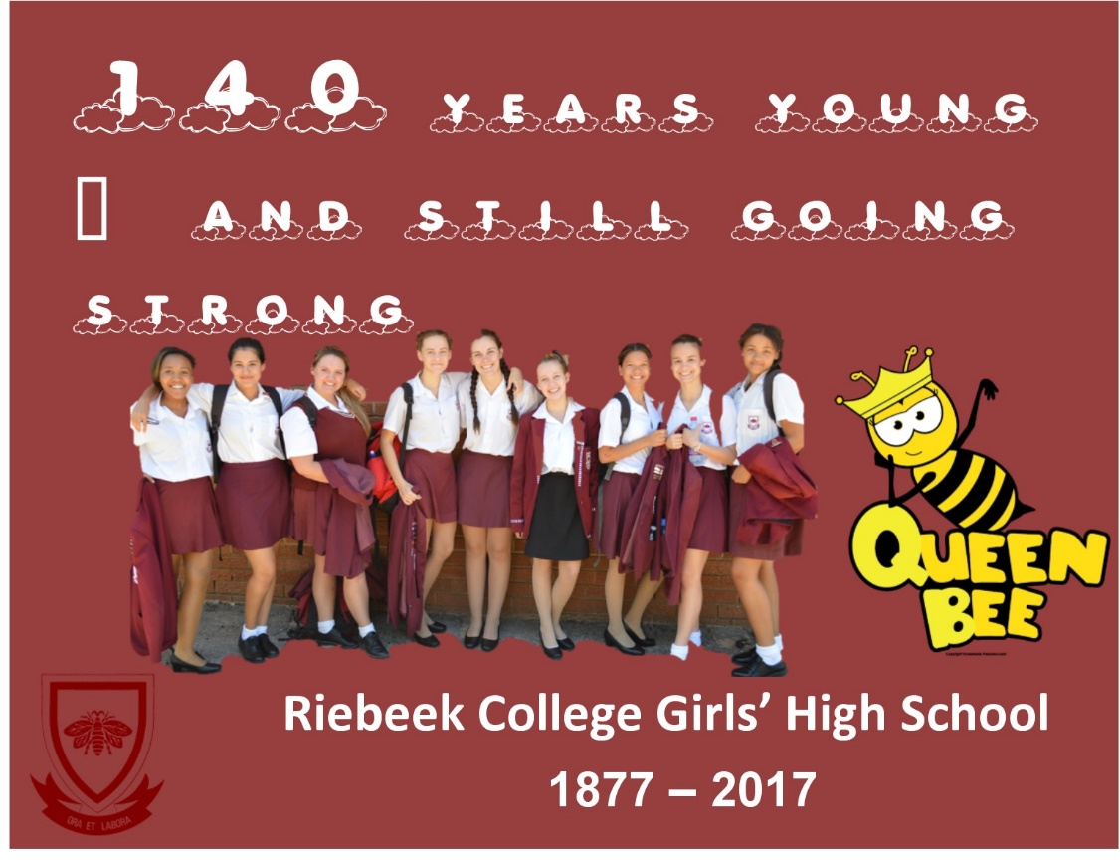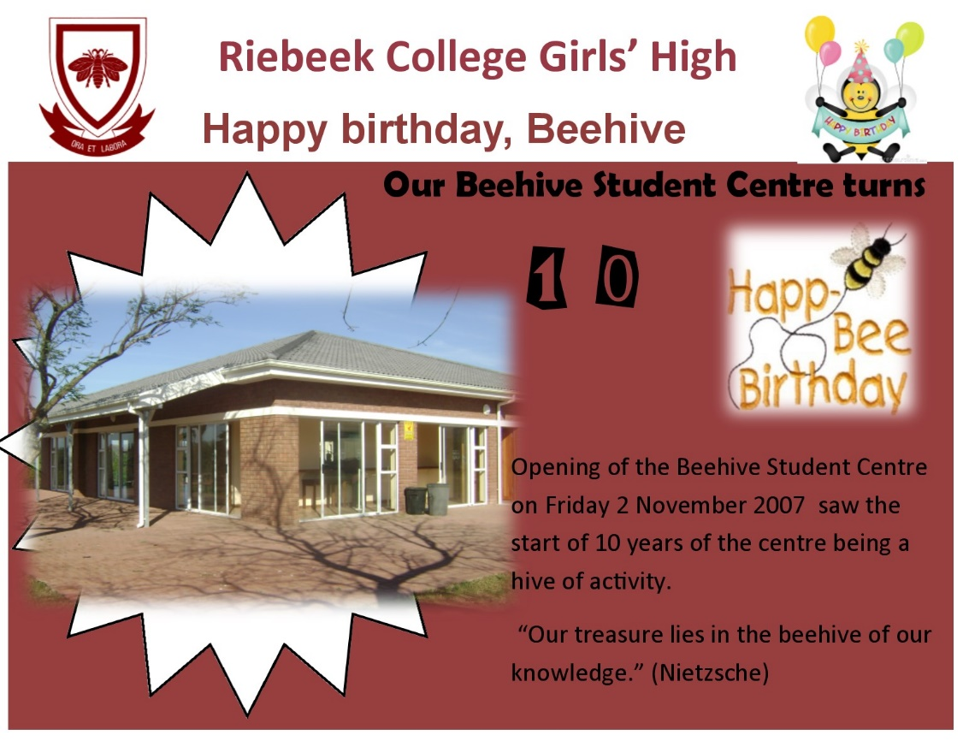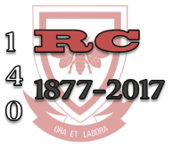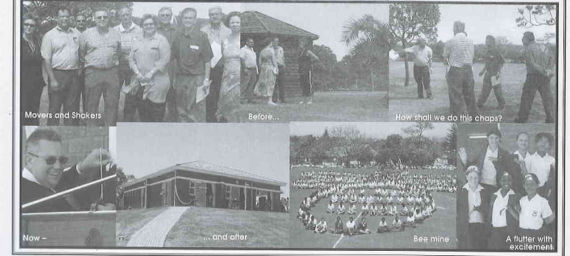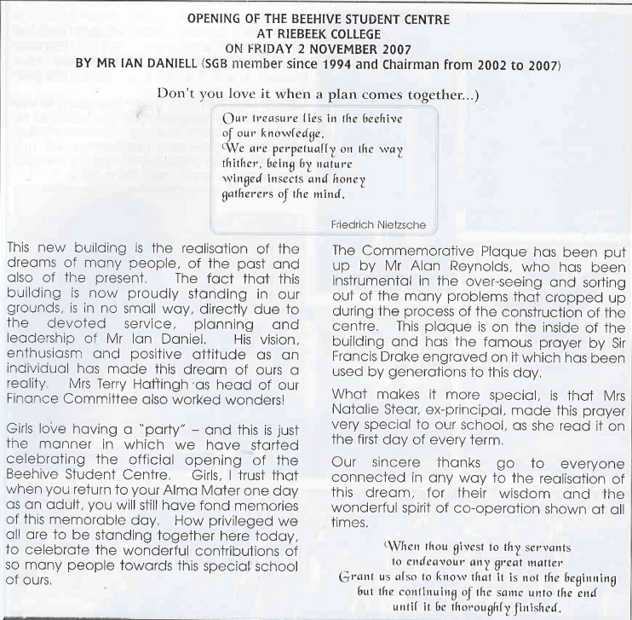

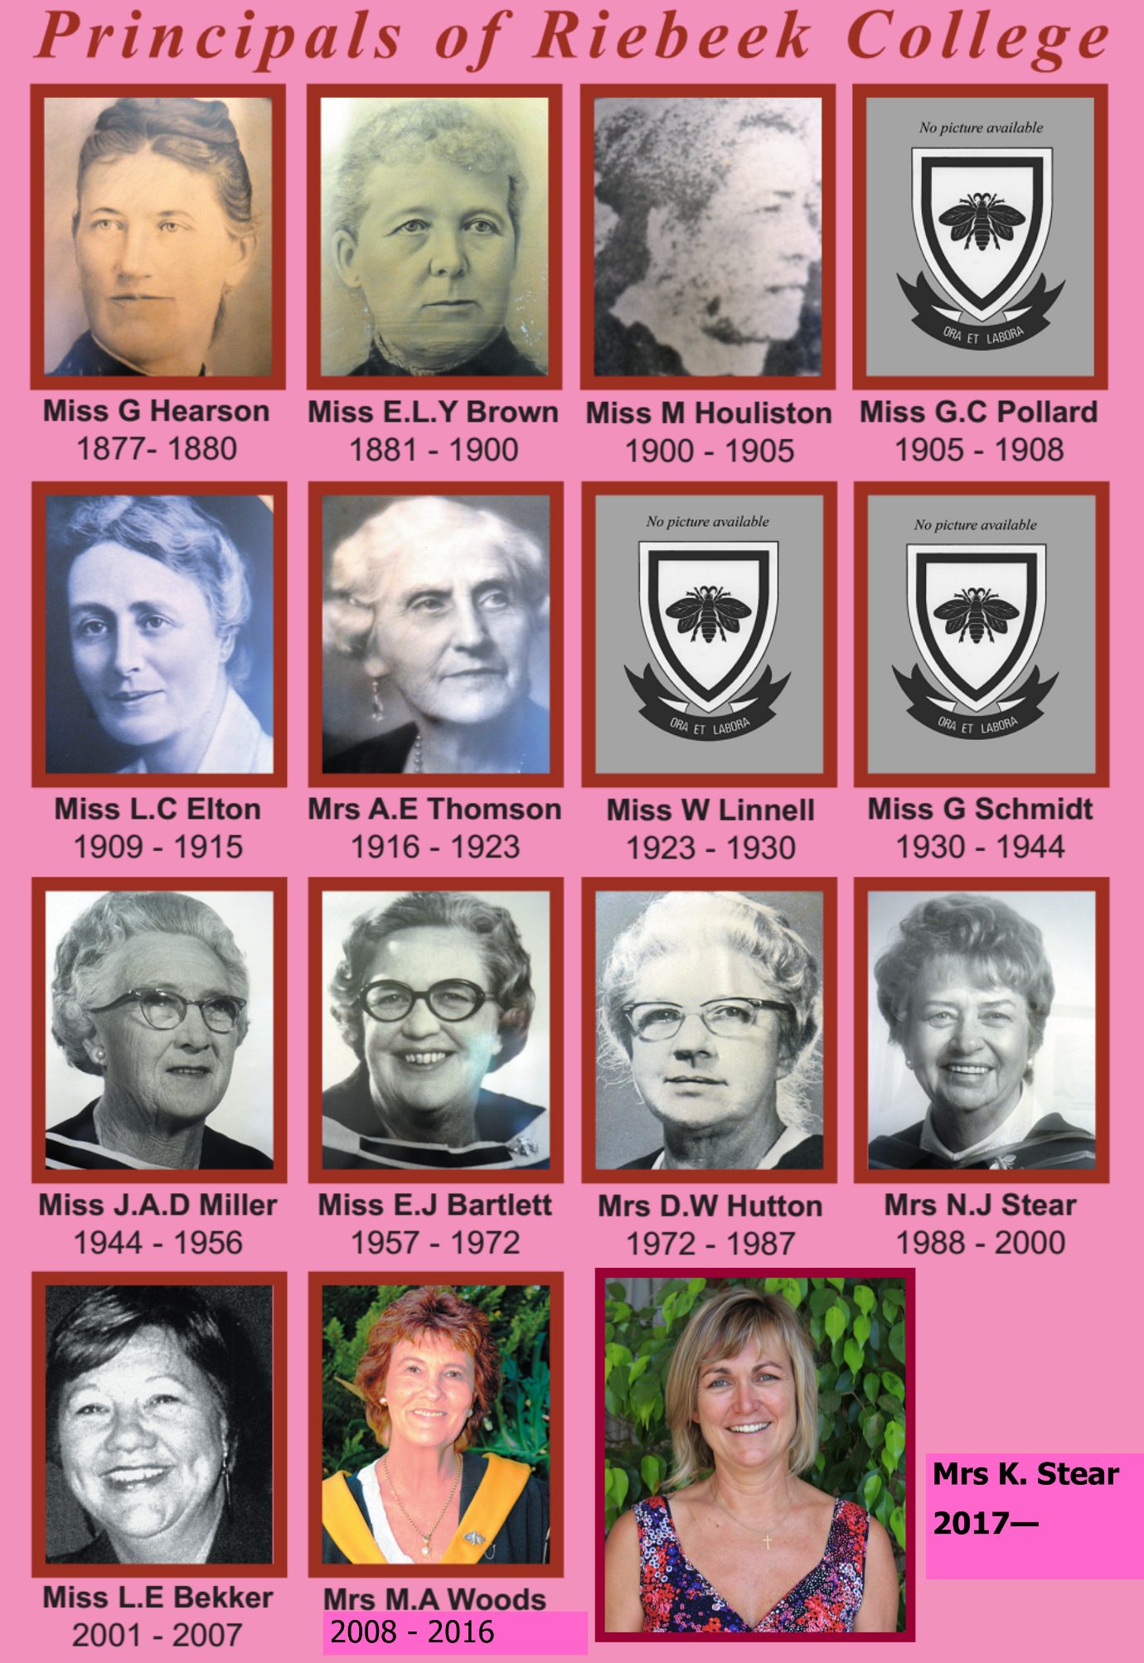

It has become a tradition to read Mrs Rose Loggenberg Hartman’s letter written in 1999 to Mrs Natalie Stear, principal from 1988 to 2000, recounting the origin of the Silver Riebeek “Bee” Pin motif. She wrote: “Miss Brehm who was a staff member of the school, while on a visit to London, commissioned a jeweller to fashion the “Bee” into a brooch, intending that it be worn as part of the school uniform. This idea proved to be non-feasible and contented herself that only one is made for her. One day, while on a visit to our home, she presented this to my sister, Dorothy, who treasured it as a gift from a valued family friend. Subsequently, Dorothy handed “The Bee” to Miss Bartlett, intending it should be held in trust for each succeeding Headmistress of Riebeek College to be worn when the occasion deemed it fitting. This was a happy gesture lending an added charm to the tradition. It only remains for me to wish you a most successful, memorable and joyous linking of hands with the past on this day, and that Riebeek College continues its successful path into the future.”

During Apartheid, Riebeek College was a whites-only school and had been immune to the marches of the children in the black community. They had been shielded away from the truth, of how many black learners were killed fighting for their educational rights.
Riebeek hadn’t been directly affected by Apartheid as they had been shielded from the truths of the schooling systems in the townships. Though the girls at Riebeek were being denied the interaction and advantages of multi-culturalism, the girls were not aware of this. In the 1980s when Riebeek bordered on an area where there was mass mobilisation, a few bomb drills took place but schooling continued as normal. The atmosphere or climate at Riebeek had remained “consistently good and sound” says Principal Mrs Woods.
In 1990, October 16, Riebeek College had made history when out of the 622 parents who had voted that Riebeek should open its doors to people of all races, 536 had voted “yes”. (86% of 90, 5%). Riebeek was the first school to set the wheels of change moving to a democratic and non-racial schooling system.
Since the advent of democracy in 1994, Riebeek had still remained consistently good and sound, concentrating on ensuring that all the young ladies at the school felt safe. The only thing that had changed was the number of black students or students of another race except white, since Riebeek had been the first school to vote to open its doors to other races in 1990. So, since 1994, the numbers of learners of a different race has increased.

Interviewee #1
Mrs Marilyn Woods
Mrs Marilyn Woods is currently the principal of Riebeek College. Sadly, this is her last year at Riebeek College, as she will be retiring at the end of the year. Mrs Woods had been at Riebeek since 1957 as first a student and then later a teacher, head of department, deputy principal and then principal in 2008. She has been at Riebeek College for over 6 decades.
- Before 1994, what was the atmosphere like at Riebeek?
I would say that the atmosphere at Riebeek has always been the same- girls are girls, and women are women, no matter what their colour or religious persuasions. What you perhaps mean by “atmosphere”, I think I have always seen as the “climate” at the school and it has remained consistently good and sound, concentrating on ensuring that all the young ladies at the school feel safe, loved and valued. Only then, can we get them to the “thinking brain”.

- What was the atmosphere after 1994, then?
- I think I have already answered this question. At Riebeek it has always and still is, about the children. It never ever made any difference when the demographics of the school started to change. It was always about the children. So, any adaptations and changes that were necessary have always been considered in the best interest of the children at school, no matter what colour or culture. That is why the climate at the school has been so constant.
- I truly know this, as I have been involved at Riebeek College firstly as a child, teacher, head of department, deputy principal and then principal, since 1957 and this is why I can proudly say that Riebeek ladies educated at this school over all the decades, have continued to graduate from this school with a sound moral compass and a solid foundation on which to build their futures.
- Of course, coming from an apolitical atmosphere, 1994 brought a greater consciousness of political issues.

- What were you thinking when Riebeek voted?
When Riebeek voted in October 1990, it was one of the highlights of my career. We all knew that the Apartheid system was grossly unfair, cruel and educationally unsound. So, we were extremely motivated and excited at the prospect of being allowed to “open” the doors of Riebeek College to all races. We willingly worked around the clock to contact each and every parent at the school, as we were passionate about at last, being allowed to do what should have been done years ago. My memory is one of sheer excitement and expectation of the school being enriched by being allowed to house young ladies of all colour and nationalities.

- What about the results?
- The results were overwhelmingly in favour of becoming what was then called a former Model C school.
- It was just what we had worked so hard for and we were ecstatically happy and filled with enthusiasm for the future.

- How did the numbers increase?
- It wasn’t an instant increase, but steadily as the years has passed, more and more young ladies wanted to be enrolled at Riebeek College. This demand is still very evident as every year we still have many, many more applications than what we can accommodate.
- Almost the entire Primary Section of the school has been housed in prefabricated classrooms since 1972 and now, every possible room in the school has been converted into a classroom.
- I would say that we are as big as we should be now, if we wish to maintain the “personal” touch that we afford all our young ladies.

- Were people against the results?
- I suppose there must have been some people who were afraid of change. However, if there were, we (the staff and school) were oblivious, I must say.
- The majority voted for it, so we were happy at the prospect of Riebeek continuing along the path of being a school where young ladies in the community are given the opportunity of being allowed to develop in totality.
- We were also very proud of the fact that we were the first school in the country to officially vote to open our doors. We were even on television! This was largely due to our principal at the time, Mrs Natalie Stear, who was very pro-active and made it her business to jump right in and get the job done.

- Are people still against the vote of opening the school to all races?
Definitely not, as they all have a choice. No one forces them to come to Riebeek College.

Interviewee #2
Doctor Rika Boucher
Doctor Boucher matriculated in Kimberley. She started teaching at Riebeek College in March 1988. She started teaching Afrikaans Home Language and currently she teaches Afrikaans First Additional Language. She is a HOD at Riebeek College. She received her Doctorate in the late 1990’s.

- Before 1994, what was the atmosphere like at Riebeek?
There wasn’t much of a difference before 1994 or after 1994. What we focused on was giving our children an education.

- And the atmosphere after 1994?
The atmosphere didn’t change. As I said there wasn’t much of a difference before or after 1994.

- What were you thinking when Riebeek voted?
Nervous, new cultures were going to come in and we didn’t know how to approach that.

- What about the results?
We were happy with the results. Like I said we were nervous about the different cultures. It was new to us.

- How did the numbers of learners increase?
The numbers grew steadily over the years.

- Would you say people are still against this vote?
I don’t think so. Everyone has a choice maybe outside people do but as far as I know, no one is against so.

- Were people against the results?
No. As I said everyone has a choice.

Interviewee #3
Mrs Sandra Gerber
Mrs Sandra Gerber is an Old Girl having matriculated at Riebeek College in 1988. She is a Head of Department at Riebeek College and has taught there, since 2000, having taught at Umtata High School and Westering High School.
- Before 1994, what was the atmosphere like at Riebeek?
When I was in matric at Riebeek in 1988, the school had some tense parents. There would sometimes be South African Defence Force vehicles lining the area between the suburb Riebeek is in and the Langa area. There was a fear that Riebeek would be a target for the mass mobilisation to spill into the white areas. Uitenhage was a politically conscious area and there had been much political activity. As a result, we would have bomb drills to be ready for any onslaught. There was though a more questioning attitude among learners with a liberal school teacher, Mr Jooste, teaching History with some realities as opposed to the National Christian Education system of the National Party. As a result, our matric class listened to Johnny Clegg songs (and saw this as a form of being liberal!) and envisioned a better country although we were not fully aware of the human rights violations of apartheid as press censorship and the divisions of the apartheid system meant a white learner did not know the whole truth. It was only from 1996 that the true extent of what apartheid entailed was revealed in the Truth and Reconciliation Commission hearings.

- What was the atmosphere after 1994, then?
By the time I returned to Riebeek to teach here in 2000 it was clear that music in the form of the Choir had become representative of the changes in the school and the Choir performed classical numbers and ethnic numbers. The atmosphere was positive. The girls then and now still choose at break to sit with people of the same ethnic group with only a few exceptions. However, this is not a problem as it is by choice and not because a government has enforced this. When curious people asked teachers at Riebeek, what the demographic percentage of whites in the school was, teachers were hard-pressed to say as they really did not look at the class in front of them in terms of what culture each person was from. Of course, there were teaching problems with cultures combining, for example:
- Language barriers
- Assumptions that a teacher was being racist because only the black girls got punished
- Assumptions that a learner was being disrespectful because she did not make eye contact whereas it was a sign of respect in that culture
- Religious views that differed
- Whether Muslim learners could wear headscarf during Ramadan and whether braid for black girls was acceptable

- What were you thinking when Riebeek voted?
Knowing that Riebeek was a progressive school, as an Old Girl I felt proud that Riebeek was taking the initiative in getting a better, fairer education system in place. However, change did not take place overnight and the intake for the next year was small and gradually increased which may have been hard for the learners of colour being such a small minority in the school but did allow for a natural assimilation and adaption.
- What about the results?
*The teachers who were at Riebeek at that time still talk about the excitement of the time.
- How did the numbers increase?
When I matriculated in 1988 from Riebeek College, there were no learners of colour. When I returned to teach here from 2000 to the present the demographics had changed in a positive manner. I had taught at Umtata High School which was a multi-cultural school in the Transkei that had allowed mixed races as it was in a homeland and was a Department of Education of South Africa school. There was an ease among learners and no tip-toeing about race as those learners had grown up together. I was pleased to see the same kind of ease at Riebeek.

- Were people against the results?
I was not at Riebeek when the vote took place, but I saw on television and only excitement. The statistics of those results certainly prove that the majority were in favour and not against.

- Are people still against the vote of opening the school to all races?
Definitely not, as Riebeek College has been very successful in celebrating the diversity of our school with such events as Cultural Civvies Day, special assemblies for Heritage Day, Social Sciences and History lessons that emphasise racial sensitivity.

TABLE OF COMPARISON (using school magazine)
Year of magazine | No. of matrics of colour | No. of staff of colour
1990 | 0 | 9
1994 | 9 | 14
2010 | 51 | 14
2014 | 54 | 14

The inclusive education/society of Riebeek has seen the school flourish with a winning choir in national competitions and renowned Traditional Song. It is evident that Riebeek has celebrated diversity. In 2010 Riebeek was on national television when their ethnic song “2010” was performed.
Mrs Natalie Stear describes Nelson Mandela’s release and the impact of Riebeek: “After his release from imprisonment of 27 years, I said the following words to our learners (whatever happened to that perfectly suitable word ‘pupils’) in the morning assembly: “I would be failing in my duty if I did not refer to the momentous events, which have occurred in the last week. Since the turn of the month, from the beginning of February, decisions have been made by our State President which have set the stage for the act to begin, in what is already being called “The New South Africa” ‘You sitting here today, particularly the Standard Two’s (now Grade 4), may have cause to remember this time as a historical occasion. Perhaps when you are old, you will tell your grandchildren about your memories of this past week and the weeks that lie ahead. Perhaps the whole school system as you know it today would have altered by the time you write matric. (For Grade 4’s that would have been in 1998 with Kerry-Lynn Thomson as Head Girl) Perhaps there will be an entirely non-racial system in which your school will no longer consist of a “Whites-only” group. Whatever happens, an exciting future awaits you. Many years ago, in the early 1960s, the British Prime Minister, Harold McMillan, said, “The wind of change is blowing through all Africa.” We are now at the stage when we are aware that the wind has indeed blown, and the results for us must mark the beginning of a new South Africa.”
She then described the vote to open the school: “That was in February. In October we were the first in the country to go to the poll to vote to open our school. With 86% of the 90.5%, who exercised their right to vote, our parents answered with a resounding “yes”. We made national headlines in the press, the radio and television. Headlines such as “Full Marks to Riebeek”, “Famous Girls’ School Votes Yes”, “Riebeek First to Vote ‘Yes’ to Open Schools”, “Riebeek Shows the Way to New South Africa”, and many more, were splashed across the front pages of the South African press on the morning of 16th October. We were very proud of the vision of our parents and grateful for their trust in our ability to handle the changes to come. How did we become the first school in the country to go to the vote? We had to give our parents 14 days notice of the election and I took advice from a senior lawyer that we were entitled to count the first day on which the notice was delivered. Our learners had to sign to take responsibility for giving the notices to the parents and the following morning, the slips with the parents’ signatures were returned. We checked up on everyone. I was keen to include the parents of all the learners as the matrics were almost ready to go into recess for their finals. I did not know that our school was the first to act so promptly until about two days before we were due to vote. Cathy Simpson was our head girl at the time and her and her prefect body can take pride in that momentous occasion. They can say with our soccer fans: “Ayoba – I was there.”And now, I look at the hall before me and I am reminded of words that I wrote in the school magazine of that year: “I believe that every child should be given an equal opportunity to receive a sound education. The education we offer should not be based on race, colour or creed – but rather on what is suitable for each child who enters this institution.” Riebeek has continued to offer that sound education – which regrettable, is still not the experience of many a child in many a school – after 16 years of democratic rule in our land! It’s a sad day when children have to report to the press that they have to share textbooks and that their teachers are not present in the classroom – and then are censured for daring to lodge their complaints to the world at large. May the day soon come when each teacher and each principal in our country say, “I am responsible.” Only then will we have learners showing pride in their schools, as we do in Riebeek College today. “
Riebeek College made history in October 1990 when out of the 622 parents who voted to open Riebeek doors to people of all races, 536 voted ‘yes’. Before the 1990s, laws were set in place to divide all people of colour and schools were allocated to the different racial groups. It was one school, our very own Riebeek College, which applied first to open its doors to people of colour. A vote was taken by parents on the 15th October 1990 and in the Evening Post of 16th October it was written that Riebeek, “has voted overwhelmingly yes, setting a shining example for the rest of the country.” This is indeed true. In a political climate that was unstable, Riebeek College put its foot down firmly and began the process to open its doors to girls of all races. Through this, Riebeek has shown her dedication and passion for education and that women have a right to proper education irrelevant of their skin colour.

Of Riebeek’s overwhelming ‘yes’ vote, Llewellyn Williams said, “We in the Eastern Cape are normally seen as the ‘backwater’ of South Africa and it really is wonderful to be part of this positive attitude which presently manifests itself amongst a certain group of schools in our area.” Another member of the Uitenhage community supported the opening of schools doors by saying that it is the “only morally acceptable educational principle” to do so. This is testament to the fact that the members of the Riebeek family and Uitenhage have a strong sense of will, humanity and ubuntu.
Many people felt that Riebeek would not be supported in their attempts, but Riebeek received much acclaim and support from people around the country. One of these people was Eddie Trent of the Democratic Party MP for Port Elizabeth. The VW Community Trust said that they looked forward to possibly assisting Riebeek College to show the world that Black and White South Africans are working together to build a strong Uitenhage and strong South Africa.
Riebeek was the first school to set the wheels of change moving to a democratic and non-racial schooling system and will forever leave their mark in South African history. The school gave hope to the rest of South Africa that change was coming and that a nation of empathetic people was being born. The educators and parents at Riebeek could not have imagined that their actions would one day result in Riebeek becoming more than just a multi racial school nurturing 700 girls but a second home and safe haven too. South Africa is truly alive with possibility.

Riebeek Houses: Eleanor, Elizabeth and Elton
By Sharné Knoetze

School spirit, team work and camaraderie are the result of fun inter-house competition. Riebeek’s Houses: Eleanor, Elizabeth and Elton, represented by the colours yellow, blue and green, have one ultimate goal each year- to win the House Shield.

All dressed up for the occasion with bold colours and cries, the girls vigorously compete in various sports, academics and cultural activities. Each activity provides the opportunity to earn much needed points, which all add up at the end of the year.

The Riebeek house system was officially established in 1924, 47 years after the school was founded. Initially, the school’s learners were divided into two houses for purposes of sports competition. One house was named Eleanor, after Miss Eleanor Brown, a past headmistress in the late 1800s, and the other house was named Elton, after Miss Lucy Elton, headmistress in the early 1900s.

In 1954, another house was added to the expanding school. The new house was to be called Elizabeth, after Queen Elizabeth. The colour of the new house was blue, because of the blue sash that Queen Elizabeth wears, depicting royalty.

“During my 29 years as a teacher at Riebeek I saw some patterns had emerged. For instance, Elton became known for its swimming prowess, while Eleanor has shown strength academically. Elizabeth went through a bad patch at one stage, so much so that people began to wonder whether there was perhaps a hoodoo of some sort on the house. Elizabeth’s forte appears to lie in the direction of culture, ” said Mr Jonathan Ossher, past teacher of Riebeek College.

House days are an eventful occasion on the annual school calendar. This initiative, a development of Natalie Stear, headmistress in the late 1900’s, showcases the school reaching out to the community. Each house, on its appointed day, holds a special assembly during which a guest speaker addresses the school. Thereafter the speaker is awarded a sum of money which is collected by the house by means of selling “favours”. This money is then handed to a charity represented or favoured by the speaker. Elizabeth’s House Day is often held on the Queen’s birthday.
The notion that a third house should be established at Riebeek, in order to minimise hostilities at
sporting events, was initiated by Gillian Dugmore, the Head girl of 1953. It was agreed upon that this new house be named after Queen Elizabeth who had formally been crowned queen of England on 2nd June 1953. As the colour of royalty is blue, they decided that Riebeek’s newest house would be represented by this colour too. So, in 1954, the royal house of Elizabeth came into being.
By Mr J. Ossher

Change has been slow in some aspects of schools with a traditional British colonial-style ethos such as Riebeek’s, particularly in respect of houses.

The House System, as we know it, has its origin in Britain and its colonies in about 1850. It started in boarding schools where pupils were housed in various residences, which were then designated as “houses” for purposes of internal competition. This was intended to sharpen sporting skills (much like our national teams today compete on a provincial basis), but it was also thought to improve behaviour and install a sense of belonging and esprit-de-corps. This even extended to a sense of camaraderie between seniors and juniors co-operating against rival houses. Gradually the house system spread to day schools, where day-scholars were also divided into “houses”.

Riebeek, evidently, was slow in complying, for the house system was to reach Riebeek 47 years after the School was founded. However, prior to that there could well have been an ad hoc arrangement whereby, say, a maroon team and a silver team competed on a particular sports day. In 1924 the school’s pupils were formally divided into two houses for purposes of sports competition. One house was named Eleanor, after Miss Eleanor Brown, a past headmistress in the late 1800s, and the other house was named Elton, after Miss Lucy Elton, headmistress in the early 1900s. Note the anomaly: in one case a house was given someone’s first name; in the other case someone’s surname.

A significant change came about in 1953, when it was decided to add
another house to the expanding school. Little is documented but, according to the research of my informant, Mrs Merle Phipps, it is Head girl of 1953, Gillian Killeen (nee Dugmore) who must get the credit. When she went for her farewell interview with Headmistress J.A.D. Miller, Miss Miller asked her whether there was any improvement she could suggest. Gillian replied that every time they had sports competitions the school was split into two hostile camps, and that even friendship suffered. Perhaps the introduction of a third house would defuse the situation. Asked to suggest a name, Gillian replied that another “E” would be appropriate. Miss Miller then consulted the teaching staff. The new house was to be called Elizabeth, after the lady of the same name who had shortly before been crowned “Elizabeth the Second, by the Grace of God, of the United Kingdom of Great Britain and Northern Ireland and of her other Realms and Territories Queen, Head of the Commonwealth, Defender of the Faith”.

The new House came into being in 1954, with Riebeek having thus honoured two headmistresses and a queen – all three of them,
interestingly enough, starting with the letter El The colour of the new house was blue, because of the blue sash that Queen Elizabeth wears, depicting royalty. Incidentally, for those with a penchant for trivia, international tennis star Linky Boshoff, arguably Riebeek’s most famous learner, was in Elizabeth.

During my 29 years as a teacher at Riebeek, I saw little change in the house system, but some patterns had emerged. For instance, Elton became known for its swimming prowess, while, of late, Eleanor has shown strength academically. Elizabeth went through a bad patch at one stage, so much so that people began to wonder whether there was perhaps a voodoo of some sort on the house. Elizabeth’s fortẻ appears to lie in the direction of culture. One significant change took place circa 1989 during the tenure, as headmistress, of Mrs Natalie Stear, who introduced a change in the way house members were selected. Previously, one was placed into a house at random, or according to what past or present relatives one had at Riebeek. Thenceforth all new boarders were to be placed in Elton, while the hostel’s existing “old pots” were able to choose whether to migrate or not. There was initially some fear that Elton would be unfairly advantaged, as it was perceived that boarders, restricted as they were from distracting townee activities, would perform better at sport and academia. As it turned out, however, the number of boarders has since diminished considerably, and is no longer a significant factor in determining Elton’s placing in inter-house competitions.

Another development that occurred in the Stear era was House Days. Each house, on its appointed day, would hold a special assembly during which a guest speaker addressed the School. Thereafter the speaker was awarded a sum of money which had been collected by the house by means of selling “favours” – usually some little knick-knack representing the house. This money would then be handed to a charity represented or favoured by the speaker. A pleasing touch is that Elizabeth’s House Day is often held on the Queen’s birthday.

Some interesting patterns are evident when one studies the accompanying information compiled from various house reports, prize lists and trophies. Unfortunately, the list of victories is found wanting, owing to some tardy record-keeping over the years, not made easier by the fact that for 43 years Riebeek stopped producing magazines. It appears that there has been little co-operation between writers of various magazine articles. In an apparent attempt to avoid duplication of the same information in the House reports, the various sports reports as well as the prize list, writers have erred toward the other extreme, resulting in no house results at all! For instance, in the 1967 Magazine the only reference to any inter-house activity occurs in the hockey report which reads simply: “The inter-house and inter-class matches were played with a minimum of fuss.” Brevity must indeed have been the hallmark of that editor, as only one-third of the magazine is devoted to School matters (much of it literary
contributions). The other two-thirds consist of Old Girl matters!

Another reason for the large number of blank spaces is that sports and other codes have not remained constant over the years. While some, such as indoor hockey and volleyball did not feature at Riebeek in the early years, others, such as lifesaving and squash have come and gone.

What of the future? With the advent of Africanization of schools such as Riebeek, it remains to be seen whether the house system will be retained in its present form. While decentralization is not a foreign concept to Africa (for instance the division of Shaka’s armies into regiments, and the existence of royal “houses”) changes could well come about in the schoolhouse system. Modernization, too, is taking its toll on established institutions. The change will be slow, and irregular, depending on how individual schools manage the situation. In Riebeek’s case the problem lies in the abstractness of the houses – they are not visible entities, they exist in name only. Moreover, they do not have unique identifying symbols such as in the case of Muir College, where each of the four figures in its crest represents a house. In earlier years at Riebeek the houses made use of informal mascots and mottos, which are sadly lacking today. A few years ago an attempt was made to generate greater awareness by revealing the house each time an individual was singled out for praise for an achievement. Regrettably, the exercise was not sustained. There was also a move to introduce house anthems, one of which was actually sung by Eleanor at a swimming gala, but a general lack of interest put paid to such aspirations. It may be argued that learners’ horizons have broadened and that there is no place for institutions that they may see as antiquated. However, there is still a place for tradition in schools, and it would be most unfortunate if the present generation neglected to maintain a level of house consciousness, not just for old times’ sake, but also for new times’ sake.

By Mr J. Ossher

Hockey: Eleanor (1924), Elton (1925), Eleanor (1926), Eleanor (1927), Elton (1928), Eleanor (1929), Eleanor (1931), Eleanor (1932), Eleanor (1933), Eleanor (1935), Eleanor (1936), Eleanor (1937), Elton (1938), Elton (1939), Elton (1940), Elton (1941), Eleanor (1942), Eleanor (1943), Eleanor (1945),Elton (1946), Elton (1947), Elton/ Eleanor (1949), Eleanor (1950), Eleanor (1951), Elton (1952), Elton (1953), Eleanor (1955), Elizabeth (1956), Elton (1957), Elton (1968), Elizabeth (1969), Eleanor (1970), Elizabeth (1988), Elizabeth (1989), Elton (1990), Eleanor (1991), Elizabeth (1993), Elton (1994), Elton (1995), Elton (1996), Elton (1997), Eleanor (1998), Elton (1999), Eleanor (2001), Elton (2002), Eleanor (2003), Elizabeth (2005), Eleanor (2008), Eleanor (2009)

Netball: Eleanor (1924), Eleanor (1925), Elton (1926), Elton (1927), Elton (1928), Elton (1929), Eleanor (1930), Eleanor (1931), Eleanor (1932), Elton (1933), Elton (1935), Elton (1936), Elton (1937), Elton (1938). Elton (1939), Eleanor (1940), Elton (1941), Eleanor (1942), Elton (1943), Eleanor (1945), Eleanor (1946), Elton (1947), Elton (1950), Elton (1951), Elton (1952), Eleanor (1953), Eleanor (1954), Elton (1955), Elton (1956), Elton (1957), Eleanor (1958), Elton (1959), Elton (1961), Elton (1962), Elton (1963), Elton (1964), Eleanor (1965), Elizabeth (1966), Eleanor (1967), Eleanor (1968), Elizabeth (1969), Elton (1970), Elton (1972), Eleanor (1973), Elizabeth (1974), Eleanor (1975), Elton (1976), Elton (1977), Elton (1978), Elton (1979), Elizabeth (1980), Elizabeth (1981), Elizabeth (1982), Elizabeth (1983), Elizabeth (1984), Elton (1985), Elizabeth (1986), Elizabeth (1987), Elizabeth (1988), Elizabeth (1989), Elton (1990), Elton (1991), Elton (1992), Elton (1993), Elton (1994), Elton (1995), Eleanor (1996), Elton (1997), Elton (1998), Elton (1999), Elton (2000), Elton (2001), Elton (2002), Eleanor (2003), Elton (2004), Elton (2005)

Tennis: Elton (1924), Eleanor (1925), Elton (1926), Elton (1927), Elton (1928), Elton (1929), Elton (1930), Elton (1931), Eleanor (1932), Elton (1933), Eleanor (1935), Elton (1936), Elton (1937), Elton (1938), Elton (1939), Elton (1940), Elton (1941), Elton (1942), Eleanor (1943), Eleanor (1945), Eleanor (1946), Eleanor (1947), Eleanor (1948), Elton (1949), Eleanor (1950), Elton (1951), Eleanor (1952), Eleanor (1953), Eleanor (1954), Elizabeth/ Eleanor (1955), Elizabeth (1956), Eleanor (1957), Eleanor (1958), Elton (1959), Elton (1961), Elton (1962), Eleanor (1963), Elizabeth (1964), Eleanor (1965), Eleanor (1966), Eleanor (1967), Eleanor (1968), Eleanor (1969), Elton/ Eleanor (1970), Elizabeth (1971), Elizabeth (1972), Elton (1973), Elizabeth (1974), Eleanor (1975), Eleanor (1976), Eleanor (1977), Elton (1978), Elton (1979), Elizabeth (1980), Elizabeth (1981), Elton (1982), Elizabeth (1983), Elton (1984), Eleanor (1985), Elton (1986), Elton (1987), Elton (1988), Eleanor (1989), Elton (1990), Eleanor (1991), Eleanor (1992), Elizabeth (1993), Elton (1994), Eleanor (1995), Eleanor (1996), Eleanor (1997), Eleanor (1998), Eleanor (1999), Elton (2000), Eleanor (2001), Elton (2002), Elton (2003), Elton (2004), Elizabeth (2005), Eleanor (2006), Eleanor (2008)

Swimming: Eleanor (1924), Eleanor (1925), Elton (1926), Elton (1927), Elton (1928), Eleanor (1926), Eleanor (1930), Elton (1931), Elton (1932), Elton (1933), Elton (1934) Elton (1935), Eleanor (1936), Eleanor (1938), Eleanor (1939) Eleanor (1940), Eleanor (1941), Eleanor (1942), Eleanor (1943), Eleanor (1944), Eleanor (1945), Eleanor (1946), Eleanor (1947), Eleanor (1948), Eleanor (1949), Eleanor (1950), Elton (1951), Eleanor (1952), Elton (1953), Elizabeth (1954), Elton (1955), Elton (1956), Elton (1957), Elton (1968), Elton/ Eleanor (1969), Elton (1970), Elton (1988), Elton (1989), Elton (1990), Elizabeth (1991), Elton (1992), Elizabeth (1993), Eleanor (1994), Elton (1995), Elton (1996), Eleanor (1997), Elton (1998), Elton (1999), Elton (2000), Elton (2001), Elton (2002), Eleanor (2003), Eleanor (2004), Eleanor (2005), Eleanor (2006), Elton (2008), Eleanor (2009)

Athletics: Elton (1924), Eleanor (1925), Eleanor (1926), Eleanor (1927), Eleanor (1931), Eleanor (1932), Elton (1989), Elton (1990), Elton (1991), Elton (1992), Elton (1993), Elton (1994), Elton (1995), Elton (1996)

Indoor Hockey: Elizabeth (1990), Eleanor (1996), Eleanor (1997)

Volleyball: Eleanor (1988), Elton (1989), Elizabeth (1990), Eleanor (1991), Elton/ Eleanor (1993), Elton (1994), Elton (1995), Eleanor (1996), Elton/ Eleanor (1997), Eleanor (1998)

Squash: Elizabeth (1988), Elton (1994), Elton (1995), Eleanor (1996), Eleanor (1998)

Lifesaving: Eleanor (1995)

Cross- country: Elton (2003), Eleanor (2004), Eleanor (2005)

Badminton: Eleanor (1996), Eleanor (2004), Elton (2005), Elton (2006), Elton (2008)

Debating: Elizabeth (1967), Elton (1968), Eleanor (1969), Elizabeth (1970), Eleanor (1971), Eleanor (1972), Elton (1973), Elizabeth (1974), Elton (1975), Elton (1976), Eleanor (1977), Elton (1978), Eleanor (1979), Eleanor (1980), Elizabeth (1983), Eleanor (1984), Elizabeth (1985), Eleanor (1986), Elizabeth (1990), Elizabeth (1991), Elton (2001), Elton (2004), Elizabeth (2005)

Plays: Elton (1988), Eleanor (1989), Elton (1991), Elizabeth (1992), Elton (1993), Elizabeth (1994), Elton (1995), Eleanor (1996), Elton (1997), Elizabeth (1998), Elizabeth (1999), Eleanor (2000), Elton (2001), Elizabeth (2002), Eleanor (2003), Elizabeth (2004), Eleanor (2005), Elizabeth (2006), Elizabeth (2007), Eleanor (2008), Elizabeth (2009)

Chess: Elizabeth (2004)

Quiz: Elton (1996), Elizabeth (1999), Elizabeth (2003), Elton (2004), Elizabeth (2005), Eleanor (2009)

Scholarship: Eleanor (1924), Eleanor (1925), Elton (1926), Eleanor (1927), Elton (1928), Eleanor (1929), Eleanor (1930), Eleanor (1931), Eleanor (1932), Eleanor (1933), Eleanor (1934), Eleanor (1935), Eleanor (1936), Eleanor (1937), Eleanor (1938), Elton (1939), Elton (1940), Elton (1941), Elton (1942), Eleanor (1943), Elton (1944), Eleanor (1945), Eleanor (1946), Eleanor (1947), Elton/ Eleanor (1948), Eleanor (1949), Eleanor (1950), Eleanor (1951), Eleanor (1952), Eleanor (1953), Elizabeth (1954), Elizabeth (1955), Elton (1956), Elton (1957), Eleanor (1968), Eleanor (1969), Elton (1988), Eleanor (1989), Eleanor (1990), Eleanor (1991), Elton (1992), Eleanor (1993), Eleanor (1994), Elton (1995), Eleanor (1996), Elizabeth (1997), Eleanor (1998), Elton (1999), Elton (2000), Elton (2001), Elton (2002), Elton (2003), Eleanor (2004), Elizabeth (2005), Eleanor (2006), Eleanor (2007), Eleanor (2008)

House Shield: Eleanor (1929), Eleanor (1930), Eleanor (1931), Eleanor (1932), Elton (1933), Elton (1934), Eleanor (1935), Eleanor (1936), Elton (1937), Eleanor (1938), Elton (1939), Elton (1940), Elton (1941), Eleanor (1942), Eleanor (1943), Elton (1944), Eleanor (1945), Eleanor (1946), Eleanor (1947), Elton/ Eleanor (1948), Eleanor (1949), Eleanor (1950), Elton (1951), Eleanor (1952), Eleanor (1953), Eleanor (1954), Elizabeth/ Eleanor (1955), Elton (1956), Elton (1957), Eleanor (1958), Elton/ Eleanor (1959), Elton (1960), Eleanor (1961), Eleanor (1962), Eleanor (1963), Eleanor (1964), Eleanor (1965), Eleanor (1966), Eleanor (1967), Eleanor (1968), Eleanor (1969), Elton (1970), Elton (1971), Elizabeth (1972), Elton (1973), Elizabeth (1974), Elizabeth/ Elton (1975), Elizabeth (1976), Elizabeth/ Eleanor (1977), Elton (1978), Elizabeth (1979), Elton (1980), Elton (1981), Elton (1982), Elizabeth (1983), Eleanor (1984), Eleanor (1985), Elton (1986), Eleanor (1987), Elton (1988), Elizabeth (1989), Elizabeth (1990), Eleanor (1991), Elton (1992), Eleanor (1993), Elton (1994), Elton (1995), Eleanor (1996), Eleanor (1997), Eleanor (1998), Elton (1999), Elton (2000), Elton (2001), Elton (2002), Eleanor (2003), Eleanor (2004), Elizabeth (2005), Eleanor (2006), Eleanor (2007), Eleanor (2008)

Eleanor House Report
Brown and Yellow?
By Jhené Meyer

You may well wonder what a Miss Brown and the yellow house at Riebeek have in
common. You are about to find out. The remarkable Eleanor House is named after a
remarkable woman: Miss E.L.Y. Brown. And as remarkable and successful as she was, Eleanor has lived up to her name this year!

Miss E.L.Y. Brown was the second ever headmistress of Riebeek College (1881- Sept 1900). She travelled here on a boat that was bringing
re-inforcements for the Zulu war and the officers cheered her as she left the ship – a lone woman travelling to the unknown hinterland. She came to Riebeek as a Vice Principal but she was the most efficient woman with a strong personality thus choosing her as the next headmistress seemed to be a natural decision. She raised the school standards of education and as she received her education in England, she was most successful in teaching English Literature.

It was Miss Brown who imported the silver bee that we see Mrs Woods wear on special occasions. She intended the bee to be worn by all pupils as a school badge with the motto Ora et Labora but this proved to be too expensive. Miss Brown gave the silver bee to Miss Edie Brehm, who in turn gave it to Miss D. Loggenburg. She then presented it to Miss Jean Bertlett and later Mrs Hutton received it. This is the same bee that was worn by Mrs N.Stear, Miss L. Bekker and, today, Mrs. M. Woods.

It was under Miss Brown’s leadership that Riebeek College became a senior and junior school, that Riebeek gained a music department, an art
department, needlework classes, tennis courts, a croquet lawn laid down, a science lab with the latest equipment and that girls could start taking part in debates and the establishing of societies. The girls were now being taught academically and prepared for the university examinations.

Miss Brown spent her youth and her more mature years in building and establishing Riebeek College. During her reign the hours of attendance
became fixed. School started at 8:30 in summer and at 9 in winter. School days were five hours long and the girls had a half hour break. In 1900 she felt she could not go on. After a serious illness she applied to be allowed to resign two years before her time of retirement and so the history of
Miss E.L.Y. Brown is told.

At Riebeek College, school life
is fun and exciting! A buzzing
school calendar exudes passion
for play, compassion for charity,
craze for cultural activities and a
love for learning.
Founded 134 years ago in 1877,
this progressive school provides
Grade 4 to Grade 12 learners a
holistic educational experience
in a happy, safe and stimulating
environment. Every learner is
developed and equipped to face
the challenges of a changing
world.
The school has many traditions
handed down and developed
over more than a century. These
have helped to provide a positive
ethos which those who have
studied here value highly.
Riebeek has always been at the
fore-front of progressive change
especially since it was the first
public school in South Africa to
vote to open its doors to all races
and received national television
coverage thereof.
The school was built for 400 girls
but currently houses 689 with
Grades 5 – 7 in prefabricated
buildings since 1972.

Some Things That Don’t Change!

The Way Things Were:
Mrs Bartlett, headmistress from 1957 to 1972, wrote in the Jubilee Magazine of 1977: Looking back over the years, I have come to realise that of all the many facets of teaching, it is above all the quality of human relationships in classroom and staffroom that is important. And if I have one piece of advice to give aspirant teachers it is simply to learn to laugh; to laugh with others, never at, unless at oneself. The saving grace of shared laughter is the safety valve for so many tensions and crises and in a school, as elsewhere, there will always be these present.

The Way Things Were…
Mrs Bartlett (Headmistress 1957-1972)wrote in 1977 : “You, the pupils of today, may laugh at the idea of your being described as young ’ladies’, but I don’t think you should for throughout a century of days and weeks and months and years, Riebeek College has endeavoured to give so much more to its pupils than mere book-learning; and, in my view, a young lady is not the niminy-piminy miss of Victorian novels who swooned and called for her smelling salts at the least provocation—she is the girl, the young woman, whose code of conduct enhances her own self-respect and dignity, who conducts herself with due regard for the self-respect and dignity of others, who has acquired the virtue of self-discipline probably as a result of the efforts of her parents and teachers and who has learnt the meaning of the word ’duty’ as well as the meaning of the phrase ’the rights of the individual. And this is one of the things that our modern world seems to lack—emphasis on the quality of a sense of duty (which includes consideration for others and for differing points of view). If we thought more of the virtue of duty, our world would be a great deal more stable and our happiness a great deal more secure.”

The Way Things Were…
During the time of Miss M Houliston as Headmistress(1900-5), it was amazing how much power and influence the School Committee held and exercised. The controlled the school: They demanded a written report from the Lady Principal each month— and insisted it be written in a book not on a sheet of paper. They controlled the teachers demanding to know every move they made and where they stayed. They arranged the dates of all functions. If a teacher wished to break their contract, they almost black-balled her.

The Way Things Were…
When Miss W LInnell was headmistress from 1923-30, the Caretaker was Mr D van der Merwe. The staff knew him as David—a fine gentleman—a true gentleman of the old school. A farmer driven to the town by depression and drought, he was a father-figure and all loved him. He was faithful to the very end and only left when he got too old to work. There is dignity in labour!

At this stage the Caretaker must be mentioned. We knew him as David - a fine gentleman – a true gentleman of the old school, a farmer driven to town by depression and drought. He was a father figure and we all loved him. He was faithful to the very end and only left when he got too old to work. A rose tree he planted stands in the front garden to this day

Hostel

The Way it Was – Hostel Tea
As a direct result of the opening of the Brandwag High School, the Dutch Reformed Church quite rightly decided that its support of Riebeek College Boarding House was an anomaly, so it informed the Riebeek College Committee of its intention of selling the building and the ground. After the Brandwag High School had opened, Riebeek and Brandwag girls both attended the Boarding House.

Mrs Oglethorpe, a Riebeek Old Girl and an
adherent of the Dutch Reformed Church, had been appointed Superintendent. The position was fraught with difficulties. Boarders took sides and the atmosphere at meals and study was most unpleasant. The girls were young and naturally intolerant.

The building and grounds were sold. The new owner offered the building to Riebeek College at ₤50 a month. The Education Department was not in favour of taking the responsibility of a fresh burden so the Boarding Department closed. There were many regrets as the whole beginnings of Riebeek College in 1877 stemmed from this building. One delightful custom continued. The teachers had boarded in the building so their tea was always supplied – this was continued until the Boarding Department closed down. Many delicious scones and muffins with butter and jam were enjoyed by generations of teachers.

The Way it Was – Hostel Discipline
The combined committees met in June 1903 and a boarder was reported for defying the Lady Principal and communicating by means of notes with BOYS. She had committed a vicious crime by defying the Chairman and she said that she refused to obey the Lady Principal so the Chairman sent her home. It was confirmed that she carried on communications with boys and that day scholars carried notes to and fro. She had been warned! In due course a chastened boarder returned duly forgiven and - we hope - obedient!

The matrons agreed that there have been quite a few changes over the past couple of years. For starters, the hostel used to
consist of 72 girls. Today, there are only 28. Also, hostel girls used to have a uniform that used to be worn at supper and when going out. Today, school uniform is worn to breakfast and civvies at supper and when going out. Many years ago the Riebeek Hostel was a termly boarding school but now, the boarders leave on Fridays and return on Sunday evenings. Outings used to occur quite often at the hostel. Whether it was having supper at a restaurant or just ice-creams, hostels girls made an effort to go out and have a good time. Today, hostel girls prefer to remain indoors and go out less. As the school prefects do, the hostel prefects had a camp too: at Mrs Vermaak’s farm. Today, they indulge in a delicious supper in Mrs Vermaak’s flat, brainstorming ideas as to how to make the hostel a home away from home. The annual Boarder Banquet used to be a huge amount of work and stress for the hostel staff as it took place in the hostel. From 2007, the Boarder Banquet has been at the Lion’s Heart restaurant in Vanes Estate. Also, there used to be boarder dances. The boarders did it for the boarders It used to be a glamorous, fun filled evening and the boarders had to bring dates! It remains fun, but without boys.

How It Was – The “Old” and “New” Hostels
Mrs E.J. Olwage was the matron who had seen the inception of the “old” hostel in Cannon Street and who cared for, scolded and loved every individual boarder who spent any time under that roof. Matron Olwage must look back with satisfaction on all that she achieved there under very difficult conditions for the building was old, as was much of the equipment; but on the Sunday that Mrs E.J. Bartlett, who was the headmistress from 1957 to 1972, first entered the hostel, every corner shone and every locker bore it’s fresh and gay floral arrangement in an assortment of small containers.
She remembers the 38 pairs of girlish eyes that watched every move she made and the 38 pairs of girlish ears that listened to every nuance of her voice. It was an altogether unnerving experience for her, for youth is the sternest and most intolerant of all critics. She felt that the boarders probably summed her up a lot more quickly than she got to know them, but she has many fond memories of the happy times spent with the boarders, both at the old and the new hostels – occasions which ranged from all-day picnics at Jeffrey’s Bay to coffee-making sessions in her flat. In this sphere, as well as in school life generally, Mr McIntyre was an important and well-loved figure, especially by the “babies” whose birthday sweets “Mr Mac” never forgot.
Rather sadly, much of this intimate family atmosphere was lost with the official occupation of the New Hostel in Preller Road in January, 1970. It was perhaps inevitable that the first two years of getting the new hostel off the ground should be difficult. Virtually overnight the number of boarders doubled, the hostel staff were new and the matron retired after nearly eighteen years of devoted service. Miss Bartlett and her sister moved into the Superintendent’s flat and it was a period of readjustment, and trial and error for all. But after nine years of effort, they were proud of the modern, spacious building and of the amenities they were able to provide, as well as the furniture they had been able to have made for the New Hostel due to the funds raised through activities such as “The Big Walk” and “The Big Swim”.

Grand Old Lady Hosts Grand Old School
Changes at Zuurberg
By Miss B. Cooper

Annually, Riebeek College Girls’ High School, one of the province’s oldest and most distinguished schools, sets out on an exciting prefects’ camp to the “grand old lady of the mountains”, the
Zuurberg Mountain Inn.

However, when the fire broke out in August, the Riebeek staff anticipated that the annual prefects’ camp would no longer be held there this year.

In amidst extensive renovations and upgrading, and in spite of it being closed, the Zuurberg Mountain Inn rose from the ashes and welcomed Riebeek College to what has become a proud and warm tradition – the hosting of the prefects’ leadership camp.

“We expected to camp and eat tinned food at a campsite but we were treated to three-course meals and five-star quality service,” said Lisa Dondashe, Headgirl of Riebeek College. Despite the disaster, the Riebeek Grade 7 and 12 prefects experienced the ultimate leadership camp in the tranquillity of these peaceful
surroundings.

The fire burnt down all 35 thatched chalets, the newly built
conference centre and chapel (Eye witnesses to the fire speak of the bell ringing out throughout the fire). The damage totalled approximately R20m.

The staff at Zuurberg saw within the wreckage an opportunity to refurbish the main building, the original 1861 Manor House while the chalets were being rebuilt. It is this resilience that taught the prefects more about leadership first hand. “More than education, more than experience, more than training, a person’s level of resilience will determine who succeeds and who fails. That’s true in the cancer ward, the Olympics and in the boardroom.
Resilience is the skill and capacity to be robust under conditions of enormous stress and change.” (Harvard Business Review)

While the learners received a “lesson from geese” presentation, the ducks at Zuurberg were happily waddling around none the worst for wear for the ordeal they had suffered and with their synched feathers back to full plume.

The Way it Was…
During the time of Miss G. Hearson (1877-1880), regular examinations were held. Mrs Robertshaw tells of a first time writing examinations. These had to be written on the black board in front of the rest of the class – an embarrassing situation – disturbed by the giggles of the rest of the class. Prizegiving was a most prestigious function and were even mentioned in the local newspaper. Below is an extract taken from the “Uitenhage Chronicle” – December, 1879

The prizes which were both handsome and numerous, were then disturbed by the Chairman to the successful candidates, who were individually greeted with loud applause as they advanced to the platform to receive the well-merited rewards of their industry. At this stage the proceedings, some fine vocal and instrumental music was introduced, which, in turn, was followed by remarks from the various examiners.

We have not space to give the speeches today; suffice it to say that all the examiners expressed themselves as highly pleased with the written answers given in by the young ladies. The examiner in French (Mr A. P. de Villiers) put forward a very eloquent plea for the study of the French language but we venture to observe that the study of the English was of far more importance in this country. Business comes first, pleasure afterwards.

At 10-30 p.m. the assemblage adjourned to the dining room to partake of refreshments. Miss Baker is not in the habit of doing things by halves, and so the tables seemed literally to groan under the load of good things.

The Good Fellowship Cup
For Auld Lang Syne
(As minuted in the official Minute Books of the Riebeek College Old Girls’ Association)

In order to keep contact with the school, tennis and croquet meetings and matches had been periodically arranged with the past pupils, the teachers and the present pupils. From time in memorial the matches took place on a Wednesday afternoon on the Riebeek tennis courts and many a pleasant afternoon was spent playing and sipping tea under the cool green trees. Members of the Old Muirite Union and the Muir teachers often formed part of the pleasant company.

The matches were made interesting by the presentation of a floating trophy in the form of a silver cup. The last date of the competition was 1939. During the war years there was no time for matches.

In 1942 at an Old Girls’ Meeting, Shelagh Clark (neé Connock), the secretary, remembered the cup and produced it. After some discussion Shelagh Clark proposed and Mrs Val Brockett seconded that the cup be used as a “Good Fellowship Cup” which had to be presented at Prizegiving under certain conditions. The old cup was battered so it was eventually decided that it may be cheaper to buy a new cup. In May 1942 the President, Mrs Wicks, reported that the Good Fellowship Cup had been beautifully restored and cleaned by Mr A. Meyer and was ready to be presented to the school.

The conditions for winning the cup were as follows: This cup had to be presented to the girl who showed the “most” good fellowship towards her classmates. Naturally, all the qualities of honesty, integrity and loyalty had to be taken into consideration.
The cup did not necessarily go to the Head Girl, though the Head girl was not to be excluded. (There was a Head Girl prize). The most important condition was that the girls had to vote for this cup, under the supervision of the Headmistress and in no way were the girls to be influenced or co-erced. Only the Std. X’s had the right to vote and they were not to be prepared beforehand.

In the early years the annual Carols service had been held in the Town Hall on Sunday evenings. In 1957 a Christmas Pageant in Magennis Park took the place of the Carols Service. It was a beautiful evening and the Evening Star made its appearance at precisely the right moment. However, the singing was lost outdoors. In 1958 at the request of the churches it was agreed that Carols should be held on a Friday evening but there was much controversy as many felt attendance and atmosphere would be affected. It was thought that the new hall and stage would not be large enough nd new arrangements were made for the changeover—that remarkable piece of organisation that enables 200 girls to move off the stage —while another 200 move on without disrupting the service or leaving gaps on the stage. The Health Robinson structure stand consisted of benches, chairs, old platforms, stools, typewriter boxes, tables and benches chairs on top of tables.

Snippets from the Past: One aspect of the move to the new building was a great disappointment to the girls. No wall decorations were permitted for School Dances. The Matric Farewell organised each year by the Std 11s is the social highlight of th year and the decorations were outstanding. It was Mrs Bartlett’s habit to be at the school to check the final preparations. One year a principals’ meeting prevented her being there until midday. When she arrived, she found life-size can-Can girls adorning the walls and felt it was necessary to insist on the addition of extra frills. The Muir boys that night removed the frills. She also recalls parading through the unlighted rooms with a torch and recalls one particular couple who came under censure and who, in later years, were happily married. When the mini was in vogue, a pupil arrived at the hall wearing a rather pretty blue silk and lace garter just below the knee and Miss Bartlett writing in 1977 reported she still had it! Backless frocks were also a cause of concern and one pupil spent an uncomfortably hot evening dancing in a long sleeved school cardigan. The mini-skirts kept shrinking so Mrs Bartlett was relieved when a request was made for long evening dresses to be worn folled by a request for the mtrics to ear white. Thus, an idea that had long been simmering in Mrs Bartett’s mind: In 1968 a Debutante’s Ball was introduced with the Matrics wearing long white frocks and carrying a posy of red and white flowers—the matrics were then presented in traditional manner to the Mayor and Mayoress.

WE AWARD OUR TROPHIES WITH PRIDE...

The awards carry a history and legacy that we honour when we select a recipient. Here is some information on some of our awards.
Riebeek College Girls’High School
Prizegiving Awards ”“ The story behind the award
The Rotary Cup: Service above Self
“WHATEVER ROTARY MAY MEAN TO US, TO THE WORLD IT WILL BE KNOWN BY THE RESULTS IT ACHIEVES.” said PAUL P. HARRIS. In 1932, Rotarian Herbert J. Taylor created The Four-Way Test. The test, which has been translated into more than 100 languages, asks the following questions:
Of the things we think, say or do
- Is it the TRUTH?
- Is it FAIR to all concerned?
- Will it build GOODWILL and BETTER FRIENDSHIPS?
- Will it be BENEFICIAL to all concerned?
In the spirit of the above, the recipient of the Riebeek Rotary Cup exemplifies the Four Way Test and always strives to put service above herself. This selfless individual will work tirelessly to promote charity work and will, under the auspices of the Riebeek Interact Club, make a meaningful contribution to charity events, fundraising and organising while also displaying the characteristics of a truthful, fair, good willed, positive individual. By her nature, she has earned this award. By the results she has achieved, she has contributed meaningfully to charity work.

Rae Roup Memorial Trophy: service to the school (excluding the headgirl)
The Rae Roup Memorial Trophy honours a learner of the school who has served the school in a variety of ways and not only in the immediate area of her sphere. This supportive volunteer should ideally be a girl who will help out without seeking recognition for this, a learner who has given of her time willingly and enthusiastically to activities of the school. She would be an honourable learner who has displayed dignity and respect. By her contributions, the school has benefitted positively and her contributions have had a positive impact on the learners and staff. By what she has done, a teacher’s work has been lightened and there is an appreciation of her efforts to step up and step in when needed. It is her willingness to do more and her manner in doing this that sets her apart.

Mayor Kopo Trophy: Community Service
Cathy Simpson Trophy: Unsolicited Service to the School excluding a prefect
Cathy Simpson was the headgirl of Riebeek College in 1990. She served throughout her school career in a variety of areas. Always kind and enthusiastic, Cathy was a good friend to many and admired for her nature. Cathy studied teaching and was injured in an accident while working overseas. With a fighting spirit and heaps of enthusiasm, Cathy has undergone therapies and undertakes various projects from home. Cathy had served as Interact Head, a member of Club 13 for the top academic learners, Dance Committee Head, Junior Achievement. Cathy is fondly remembered as a school girl as compassionate, gentle and always smiling.

Panagis Trophy: Exceptional Service to a school based society
Lana (Class of 2004) and Vera Panagis (Class of 2012) attended Riebeek College. Mr Panagis has been involved in the community. Lana was very involved in, amongst others, the First Aid Club and Vera was very involved in the Computer Club. The family describe this award as an award for giving of oneself and being dedicated to the school. The thought was that the person should be exemplary in various fields but have truly excelled in one field. In the Panagis family, respecting your elders, tradition and values are important. Vera says of this award, “I hope that the recipient of this award will feel special because they see that hard work does not have to go unnoticed and that taking pride in your work is very important. I would like a Riebeek girl to always know she is special. My sister, Lana, is a wonderful role model to me and this trophy was created to recognise people who, by their efforts, are role models of how to give fully to what you choose to be involved in. The Panagis family value their ties with Riebeek.” Lana received the Good Fellowship Cup in 2004.

Yvette Hunter Trophy: Courage and Commitment to Animals

Mr Hunter wanted this trophy to be awarded in honour of his daughter, the late Yvette Hunter who attended Riebeek. The first recipient of this award was Jodi Hattingh in 2010. The recipient of this award should be a person of moral standing who has a passion for animal welfare and is a people’s person who serves people and animal causes. Ideally, the individual should be involved in the SPCA at school level and in the community. Her fundraising should benefit animals and she should have devoted time to caring for animals. At the same time, she needs to display a love of serving people. She should show that she acts without peer pressure influencing her, that she has the moral fibre to stand up for what she believes in and that she will do the right thing for people and animals, no matter how hard. She will not bow to criticism or pressure and will be unwavering in her support of animals and mankind.

Quotes of the iconic Mother Teresa to describe qualities sought:
“Not all of us can do great things. But we can do small things with great love.”
“Peace begins with a smile..”
“I am not sure exactly what heaven will be like, but I know that when we die and it comes time for God to judge us, he will not ask, 'How many good things have you done in your life?' rather he will ask, 'How much love did you put into what you did?”
“Every time you smile at someone, it is an action of love, a gift to that person, a beautiful thing.”
“Do not think that love in order to be genuine has to be extraordinary. What we need is to love without getting tired. Be faithful in small things because it is in them that your strength lies.”
“Kind words can be short and easy to speak, but their echoes are truly endless.”
“Yesterday is gone. Tomorrow has not yet come. We have only today. Let us begin.”
“Let no one ever come to you without leaving better and happier. Be the living expression of God's kindness: kindness in your face, kindness in your eyes, kindness in your smile.”
“The most terrible poverty is loneliness, and the feeling of being unloved.”
“What can you do to promote world peace? Go home and love your family.”
“If we have no peace, it is because we have forgotten that we belong to each other.”
“God doesn't require us to succeed, he only requires that you try.”
“It's not how much we give but how much love we put into giving.”
“At the end of life we will not be judged by how many diplomas we have received, how much money we have made, how many great things we have done.
We will be judged by "I was hungry, and you gave me something to eat, I was naked and you clothed me. I was homeless, and you took me in.”
“I alone cannot change the world, but I can cast a stone across the waters to create many ripples.”
She has had a strong presence on the SPCA committee. She is a caring and disciplined prefect who has taken the prefects’ oath seriously showing loyalty. She has helped out at Addo Wildlife Sanctuary. She has been a helpful member of the Media Committee. She has served admirable as the Deputy Head of Interact. Described as epic, motherly and caring by her peers; Loren is a happy individual recognised by her peers for her selfless acts. It is, thus, with pride that this premier award is awarded as the staff, learners and the Riebeek Family are immensely proud of Loren Buchner.
Citation for Awarding the Vivian Strydom Cup for Contributions to Cultural Activities

Vivian Strydom was a past mayor of Uitenhage. This cup requires a learner to be the face of culture at Riebeek and should be a young lady with public speaking ability who has poise, confidence, a love of the arts, a willingness to be involved in a range of activities in the school and a commitment to these activities over a period of time. The recipient should have supported a number of the school’s cultural events. She could have been involved in English Olympiad, Quiz, Interhouse Oratory, Induction Party, Interhouse Plays, the Cultural Board, poetry competitions or submissions to the Creative Writing section of the magazine or other publications, drama productions, Choir, Magazine Committee etc. She is recognised by the staff and her peers as “cultural vulture”or the face of culture at Riebeek. Her demeanour is that of a cultured person. She must have made positive contributions and served cultural spheres at the school. Her manner should have encouraged others to participate in cultural activities at the school.

Nikki de Groot Trophy (Best All Round Contribution in Grade 8 to 10)
Nikki de Groot was an EP swimmer, good scholar and was fully involved in the life of the school. She passed away in a car accident. Her father, Dr de Groot, was a well known medical doctor and was chairman of our Governing Body. As they were of Dutch descent, Dr du Groot as a child was in a concentration camp during World War Two. The de Groots were involved in Riebeek in the 1970s-1980s. DR ECC Van C De Groot was awarded the Freedom of Riebeek College for his contribution to the school from 1974-1985.

Dorothy Hutton Award (Participation in Junior Senior School Life ”“ Grade 8 and 9
Mrs Dorothy Hutton was headmistress of Riebeek from 1972 to 1987. She gave this award as she wished to see more recognition for Grade 8 and 9. Mrs Dorothy Hutton’s faithful companion was her dog, Wendy, who came to school every day. She was known and respected for her formal register. Mrs Hutton taught Accounting in the high school. This award recognises a learner who takes part in a variety of fields ”“ sport, cultural, service, leadership, academics. The recipient is proving to be an asset to the high school.

Yerelemou Award (Participation in Senior School Life ”“ Grade 11)
The Yerelemou sisters attended Riebeek in the 1980s. Both sisters were vibrant and engaging young ladies who strove for excellence. With excellent inter personal skills and absolute commitment to all they undertook, the Yerelemou sisters delighted with their positive natures, their love of involvement and their passion for the opportunities that school offered.
This award is given to a Grade 11 who has balanced her commitments in what is often a stressful year given the number of leadership positions and opportunities available in this grade. Elada Yerelemou matriculated in 1989 and received the Good Fellowship Cup in that year. She had served as a Junior Town Council member and Head of the Cultural Society. Maria Yerelemou matriculated in 1991, was the headgirl and received the Good Fellowship Cup. The Yerelemou sisters were particularly fond of service, cultural and academics and both shine in the cultural sphere. The recipient should have participated across a range of activities and it is noted that the involvement is in senior school life, so one should look for active and lively engagement in daily school activities as well as extra murals. The recipient then needs to be the type of girl who seizes opportunities to the full, participated fully in what she elects to be involved in, a learner who is often keen to do more and embraces opportunities and planning. She is excited about an event, she gives of herself fully in the event, she tries to involve others, she likes being involved, she enjoys promoting what she is involved in (either directly or by her example).

John Jooste Trophy ”“ Exceptional Achievement
Mr Rupert Jooste was a History teacher at Riebeek College whose father was John, a manager at Van Stadens Beach Resort. Mr Jooste wanted this trophy dedicated to his late father. When Mr Jooste himself passed away at a fairly young age while teaching in Johannesburg, the teachers at Riebeek who remembered him were very saddened. Mr Jooste wanted this award to be awarded to a learner whose achievements were beyond the norm and truly inspirational. Mr Jooste was an affable gentleman who could adapt in any company. He was a good and loyal friend and was very popular.
Young Trophy (Strength in Adversity)
You remain in control during times of hardship, even though you experience troubles in life. You have the strength to move forward and face the new challenges that await all of us each day. When the chips are down, you still manage to smile and get on with things, it shows a great strength of character - in times of great hardship you stand tall and do not let things get to you.
Walter Anderson
The Hippie Snowflake Obsidian: Memoir of a Cutter
”• Alexander Stone
Jon M. Huntsman Sr. Winners Never Cheat: Even in Difficult Times

Joey van Zyl Trophy (a well groomed girl)
Joey van Zyl owned the local school clothing supplier store in Baird Street, Marryats. As the person who provided our girls’uniform, she had a great interest that the girls wore their uniforms proudly.

School Spirit Cup (not a first team player, not a prefect
Tammy MacNicol was slightly injured in Grade 5 after taking part in an athletics event and the hockey goal posts collapsed. This did not deter her from taking part in school life throughout her school career. She was a vibrant and exuberant Riebeek girl who displayed a pride in her school and a belief in its values. Matriculating in 2000, she envisioned an award that would recognise an individual who had not yet had a chance to gain recognition ”“ she saw first team players and prefects as individuals who had by the nature of their position attained recognition. She wanted to give a spirited, supportive, involved learner an opportunity to be recognised. This cup is awarded to a girl who has an enthusiastic, supportive, encouraging, positive nature. She could be vibrant or a regular supporter and encourager. She could be a girl who seeks to embody the fruits of the spirit by living the school’s spirit of enthusiasm. She could be a learner who is able to engage other learners to participate and support. She should have a fairly good attendance at school events, such as a hockey festival, performances in a drama production or grade assembly, society’s activities, match, extra mural or event.

HISTORY OF FOUNDER’S DAYS AT RIEBEEK COLLEGE

25 March 1988 Tradition was started by the lady principal, Mrs N. S. Stear in that she held the 1st Founder’s Day Service ever.
The original script of the Riebeek College March, presumed lost had come to light only 2 days before this ceremony. Professor Quintus James, head of the Music Department at Riebeek in 1896 had composed the march.
Guest speaker was Miss Marjorie Hill, who had been a boarder at Riebeek for 6 years and who had matriculated in 1921 with high honour.
Ingrid (Lunow) McFarlane was the Head Girl

2 June 1989 Professor Charlotte Searle – recognized in nursing circles both nationally and internationally, was the guest speaker. In 1962she became the 1st nurse in SA to earn a doctorate. She held honorary doctorates from the Witwatersrand and the University of Port Elizabeth, now The Nelson Mandela Bay University.
At the age of 79 – shewas our guest speaker and she paid tribute to Riebeek College where she said her philosophy of service to mankind took root, was nourished and given shape and meaning.
The Charlotte Searle Rose was named in her honour by the SA Rose Gardens Society in December 1988 and one was planted in the rose garden in 1989 at the Founder’s Day.
Head Girl was Stephanie Mitchell

8 June 1990 Dr Jean van Onselen, past old girl, principal of College Hill Preparatory School and Senior lecturer in the Education Department of UPE was the guest speaker.
Cathy Simpson was the Head Girl
This was the year Riebeek College could open her door to all races. We were the first in the country and appeared on Television. The voting took place on Monday 15 October 1990 and the polling ran from 17:00 until 21:00.
Although Riebeek already “released “ or should I say “leaked” the results, Ministerial approval from the Dept of Education and culture was received on the 14 November 1990, fro Riebeek to change and become a Model B school from 1 January 1991.
7 June 1991 Mrs Hazel Bindon (Nee Borthwick) an old girl was the Guest Speaker and Joan (Hickson) Oliver Head Girl of 1966 said a few words.
Head Girl was Maria Yerolemou

5 June 1992 Helga Schaberg was the Head Girl
Yvonne (Dawson) Barnes Head Girl of 1967 said a few words and her class donated a gift.
Mrs Helena (Smith) McCaig was the guest speaker and she was a pupil from 1928 to 1935. She belonged to the RCOGA from 1940, was on the committee from 1959 and became VicePresident in 1960 and President in 1962. She retired in March 1988.
This was the Diamond Jubilee of RCOGA (60th)

4 June 1993 Gillian (McGillivray) Carter was the guest speaker and was a student at RC from 1948 till 1959
Head Girl – Mary- Anne Medley

3 June 1994 Denise (Smuts) Roodt from the matric class of 1981 was the guest speaker
Head Girl was Suzanne Rudman
Elizabeth (Muller) Niewoudt from the class of 1969 gave a present to the school

2 June 1995 Jeanne (Mascre) Rowles was the guest speaker. She was a South African body-builder.
Head Girl was Jennifer MacKenzie

7 June 1996 Guest speaker was Moira (Wheaton) Jackson.
This was the first time that the IN MEMORIAM was incorporated into the Founder’s Day Service
Head Girl was Ingrid Kosaber

6 June 1997 Head Girl was Natalie Woodford
A few Head Girls addressed the school:
Elaine (Smith) Dulliseer 1947
J. (Nel) Fourie 1957
Yvonne (Dawson) Barnes 1967
Jennifer (Beaumont) Baylis 1972
Claire Soine 1987

5 June 1998 Head Girl was Kerry-Lynn Thomson
Guest Speaker was Mrs J. Honey and Mrs L. Heunis

4 June 1999 Head Girl was Claire Beckett
Guest speaker was Nicola Chapman

19 May 2000 Head Girl was Nina Esselaar
Guest Speaker was Cathy Simpson (Head Girl of 1990)

18 May 2001 Head Girl was Tarryn Hargreaves
Marilyn Woods & Finlay Taylor were acting Principals – Guest Speaker was Jennifer (Edwards) Serfontein

17 May 2002 Head Girl was Leandre Vermaak
Guest Speaker was Janet (Carew) Lytwynchuk

16 May 2003 Head Girl was Michaela Hopley
Guest Speaker was Mrs Sally (Watson) Potgieter

14 May 2004 Head Girl was Cindy Rabie
Guest Speaker was June (Pederit) Orsmond
13 May 2005 Head Girl was Sharne Knoetse
Guest Speaker was Virginia Kopp

12 May 2006 Head Girl was Lynley Myburg
Guest Speaker was Val Donald Nell (Known as Madam in ETV’s Madam and Eve programme)

18 May 2007 Head Girl was Ashanti Heugh
Guest Speaker was Nicola de Jager (1982)

9 May 2008 Head Girl was Robyn Wates
Guest Speaker was Valmai (Dollery) Bubb (1969)

8 May 2009 Head Girl was Lisa Dondashe
Guest Speaker was Marilyn (Dodd) Woods (1968)

7 may 2010 Head Girl was Shannon Barry
Guest Speaker wasCarol (Dodd) Rudman

6 May 2011 Head Girl was Ciara Jackson
Guest Speaker was Samantha Brighton

4 May 2012 Head Girl was Lache Windvogel
Guest Speaker was Mary Przybojewski

3 May 2013 Head Girl was Nicola McEwan
Guest Speaker was Lynne(Thomas) Griffiths

8 May 2015 Head Girl was Yolada Mni
Guest Speaker was Bernadette Maguire (Journalist working for Carte Blanche)

6 May 2016 Head Girl Siviwe Tole
Guest Speaker Roslyn Thomson (Air Traffic Controller – class of 2006)

