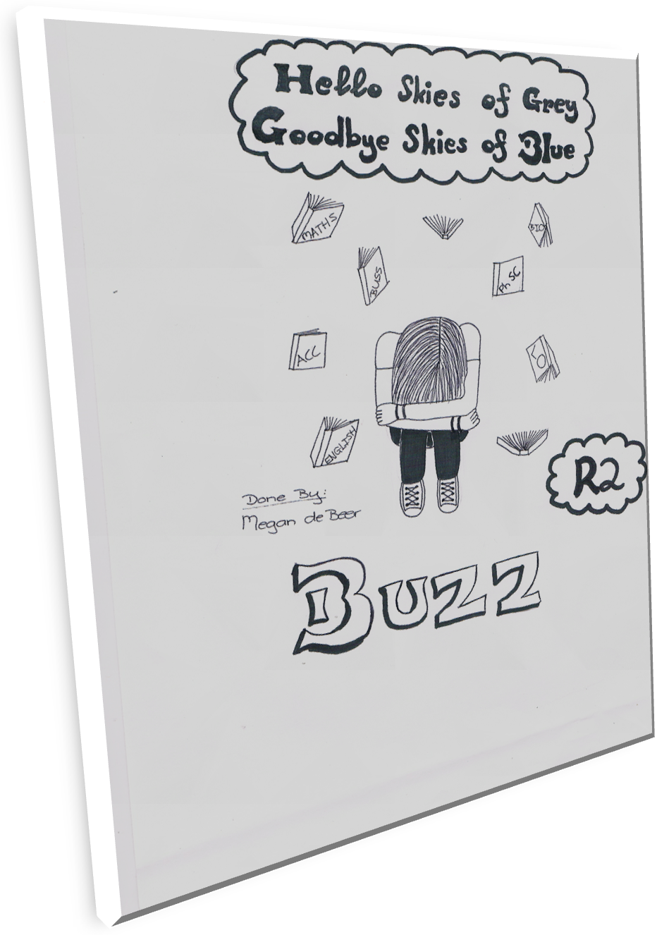

From The Editor
We have made it, girls! We’ve survived the second term! With all the hard work and effort we’ve put into the examinations, we can finally sit back and relax while reading the Buzz of course!
In this terms edition we have our out and about, things to do during our well-deserved holiday, colouring in Olaf, yummy treats to make if boredom ever strikes and many more articles to keep you entertained. We’d also like to take the time to wish our 1st Hockey team the best of luck for all their matches and tour and a happy belated birthday to Mrs. Woods! So from the Buzz team to you we hope you enjoy it ☺

Nadene.

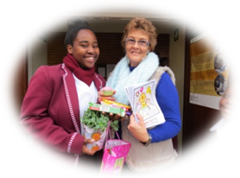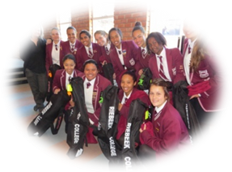

Out and About

- How Term 1 Ended

- MISS RIEBEEK
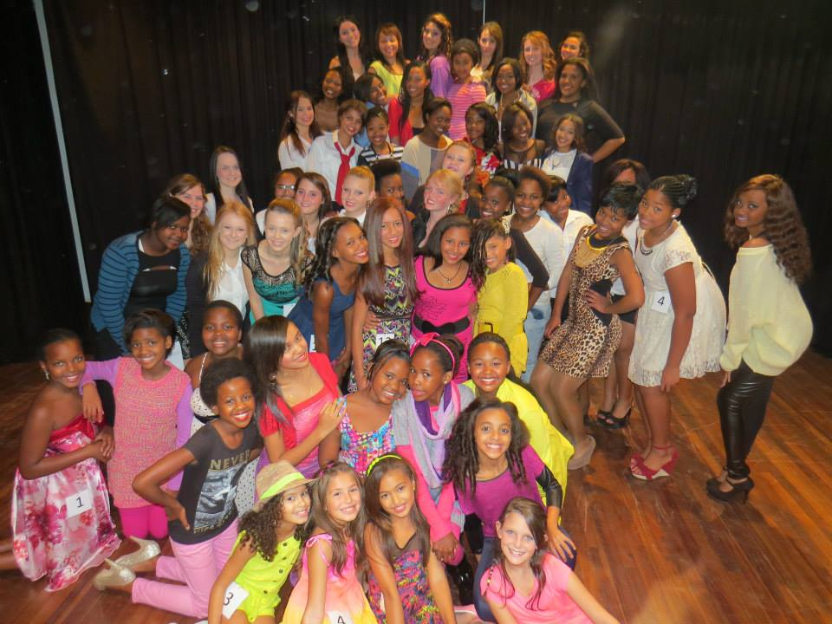
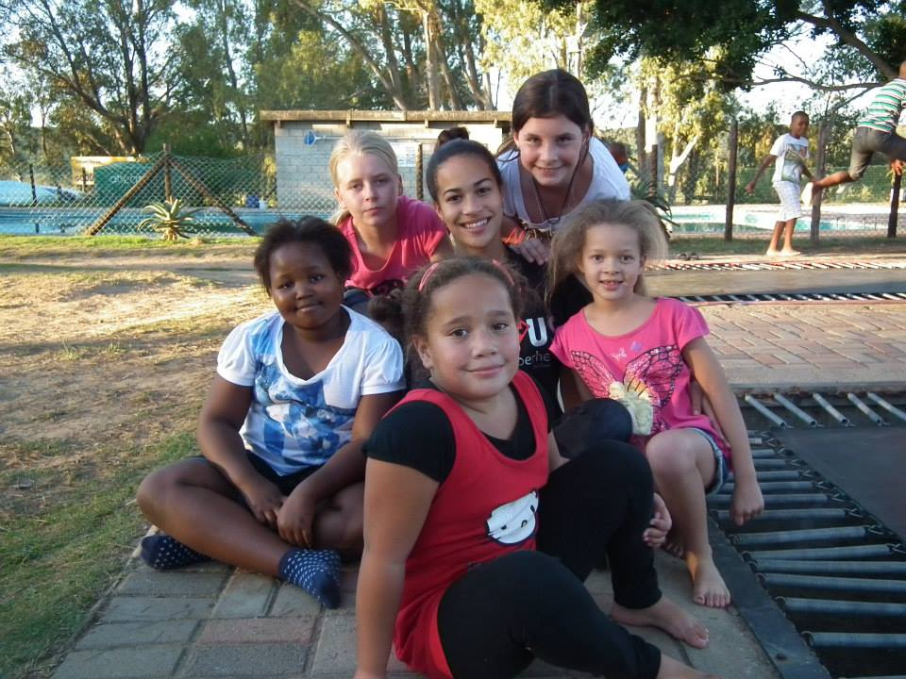
SU CAMP

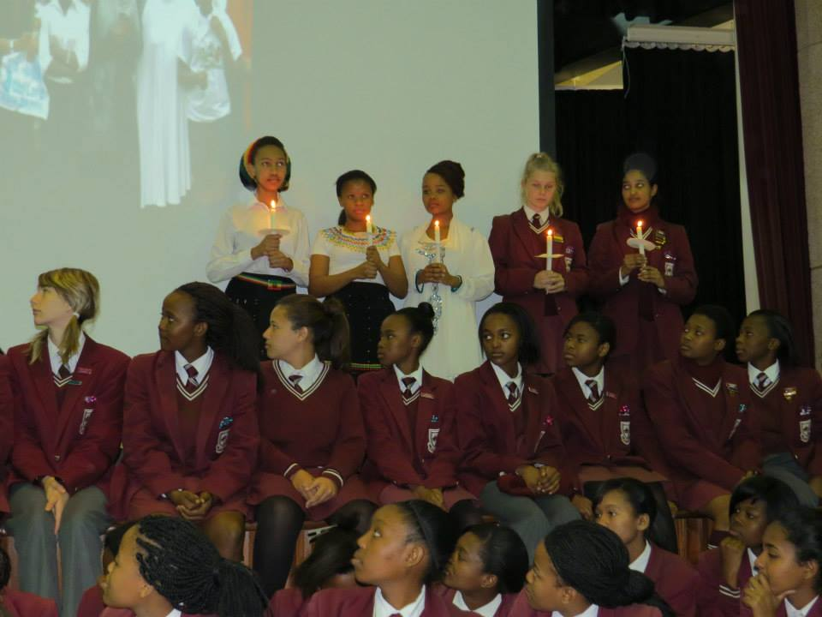
GRADE 10 ASSEMBLY
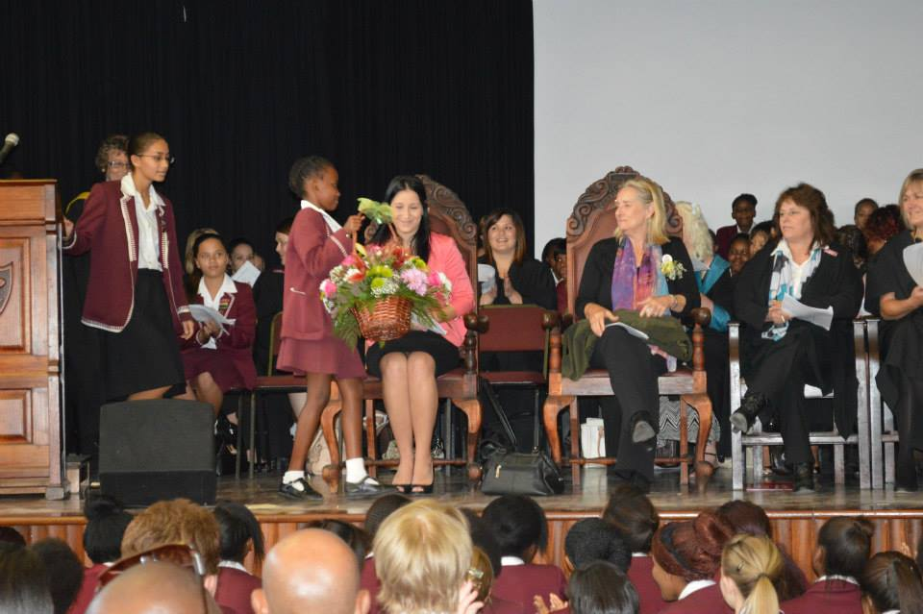
FOUNDER’S DAY

The Sporty Side of Life
On Saturday 07/06 the Senior 1st and 2nd Hockey teams played against Linkside High School. The 1st team managed to beat Linkside 1-0 despite having a number of players absent,

Junior U14A Hockey 28/5. The Junior u14A team is captained by Mishka Moosa and Ashlynne Arnolds and coached by Miss Panayiotou. They lost 3-0 to Erica.

Mini Hockey 28 May.B team lost 1-0 and A team lost 6-1 against Sunridge. Iviwe was the Player of the match for the B team game and Roshaan for the A team.

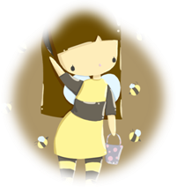

Creative Corner



Things To Get Up To These Holidays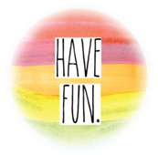

- Have a movie afternoon, great for a rainy afternoon! Rent a couple of good movies, make popcorn and snuggle up with blankets.
- Try Tenpin Bowling, make sure the bumper bars up.
- Grab your bike helmets and go for a bike ride.
- Camp out in your back yard (suitable for all ages!)
- Smile! Get the camera out and take some memorable photos.
- Paper mache, messy but always fun!
- Have theme days –make it a blue day so everyone wears blue, eats blue foods, sings blue songs, etc.
- Have a special morning/afternoon/night tea in the garden. With milkshakes and hot chocolate if you don’t prefer tea.
- HAVE FUN! ☺

Recreation

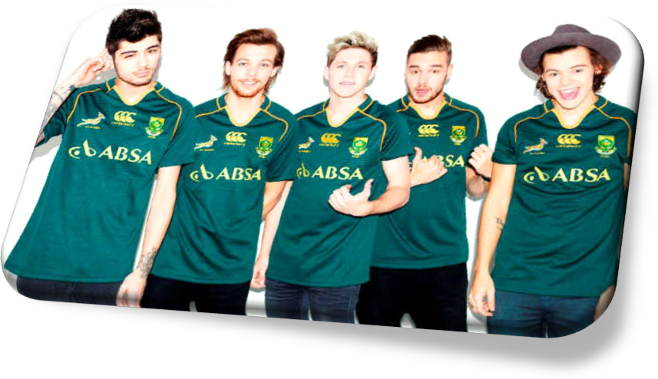
Directioners, combine a once-in-a-lifetime holiday with the chance to see your favourite band – South Africa will be the best place to catch One Direction during their world tour in 2015.
It will be their first time performing in the country, playing two nights at the world-class FNB Stadium in Johannesburg (28 and 29 March) and one night at the Cape Town Stadium (1 April), both venues during the 2010 FIFA World Cup. They join artists like Eminem, Coldplay, Rihanna and Justin Bieber in filling up these fantastic venues.
2013's Midnight Memories, the band's third album, made them the biggest-selling act in the world. They also became the first band to have their first three albums debut at No 1 on the US Billboard Chart!

A must watch movie!


The Fault in Our Stars
Drama/Romance, 8.5 Rating.
Hazel and Gus are two teenagers who share an acerbic wit, a disdain for the conventional, and a love that sweeps them on a journey. Their relationship is all the more miraculous given that Hazel's other constant companion is an oxygen tank, Gus jokes about his prosthetic leg, and they met and fell in love at a cancer support group

Just For FUN 
BLONDE JOKES

•Question: If a blonde and a brunette fell off a building, who would hit the ground first?
Answer: The brunette - the blonde would have to stop for directions!

• The assistant asked the blonde if she would like her pizza cut into six pieces or twelve."Six please" she said, "I could never eat twelve!"

•A blonde was walking down the road with a healthy looking pig under her arm. As she passed the bus stop, someone asked, “Where did you get that?"
The pig replied,
"I won her in a raffle!"

•A blonde asked someone what time it was, and they told her it was 4:45. The blonde, with a puzzled look on her face replied, "You know, it's the weirdest thing, I have been asking that question all day, and each time I get a different answer."

CAN YOU RELATE?

•When you have unlimited texting but only text about zero people
• Pulling a door that says “push” and vice-versa.
• Facebook stalking someone and accidentally liking their profile picture from six years ago.
•Going in for a hug but all the person wanted was a handshake.
•Telling someone a hilarious story and realizing that they were the one who told it to you.

DID you know ….
A birthstone is a gemstone that symbolizes a month of birth. They are often used in personal jewelry like rings or pendants.

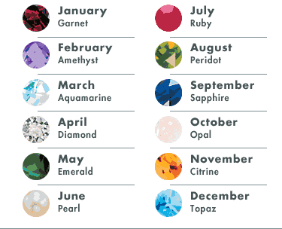

- 6 thoughts during school:
I’m tired.
I’m cold.
I don’t get it.
I’m hungry
What time is it?
I want to go home now.

- 5 things I’m not lazy at:
Eating
Drinking
Internet
Watching TV
Sleeping

- Short Stories
A 24 year old young man was looking out from the window of the train and shouted,
"Dad, look the trees are going behind!" Dad smiled and a young couple sitting nearby looked at the 24 year old's childish behavior with pity. Suddenly he exclaimed again, “"Dad, look the clouds are running with us!" The couple couldn't resist and said to the old man, "Why don't you take your son to a good doctor?" The old man smiled and said, "I did and we are just coming from the hospital. My son was blind from birth; he just got his eyes today."
Every single person on the planet has a story.
Don't judge people before you truly know them. The truth might surprise you.
Think before you say something!

Grandpa George had a failing heart. It was so diseased; his doctor told him he would need a heart transplant or die. So his name was placed on the waiting list for a donor, and each night his grandchildren prayed that if it was God's will a heart would soon be available for him. Then it happened, but not in the way anyone would have guessed, or wanted. George's grandson, Scott, was an active teenager, who loved riding his motorcycle with his friends. Scott prayed daily that his grandfather would get a heart. But he did more than just pray. He acted upon it, too. He encouraged his friends to sign organ donor cards.

The one day -a day that Scott's friends can never forget- Scott became the answer to his own prayers. He was in a terrible motorcycle accident. His friends stood around helplessly as he lay on the pavement, his body crumpled at an odd angle. The ambulance soon arrived, its sirens wailing, and sped Scott to the hospital. Their tests revealed that though his heart was still beating, he was brain-dead.

Scott's parents raced to the hospital in shock. When they heard that his death was inevitable, they knew what he would want them to come. They signed a form releasing Scott's heart to his own grandfather. The surgery was completed within a few hours, and in the following weeks Scott's grandfather recovered nicely. He told reporters, "I have a new heart; but it’s broken."

Scott's grandfather lives each day to the fullest in honor of the gift his grandson gave to him. "If I waste this life, Scott’s gift will have been in vain," he says. What about you? Somebody died so that you could live forever. That's how special you are to Him. And that's why He's coming soon to take you to live with Him. Don't waste His gift. Be there waiting to greet Him when he comes.

"Go for the Gold " by Kay Rizzo

Yummy Snacks to Make When You’re Bored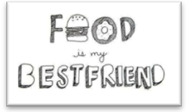
- Potatoes Shack Hack
- Potatoes’ (as many as you’ll need)
- Olive Oil
- Butter
- Salt and Pepper
Cut the potatoes almost halfway through, drizzle olive oil, butter and salt + pepper on top, bake for 40 minutes.

- Microwave Mug Cake
- A pinch of salt
- Dash of vanilla essence
- 3 tablespoons of chocolate chips
- 3 tablespoons of milk
- 1 egg
- 2 tablespoons of cocoa powder
- ¼ cup flour
- 3 tablespoons of sugar
- 3 tablespoons oil

Mix well until mixture gets right. Cook in microwave until fully cooked through with airy texture.

You’re welcome!

